Summary of the survey
These are the results of 40 responses to the survey.
85% would like to purchase the community and employment building for £1.
Suggested uses for the building:
50% Community Groups
22.5% None of the above
20% Full repair and Insure Commercial Lease
5% Parish Council run employment hub
2.5% Retail
and
80% Support the Parish Council negotiating a change of use

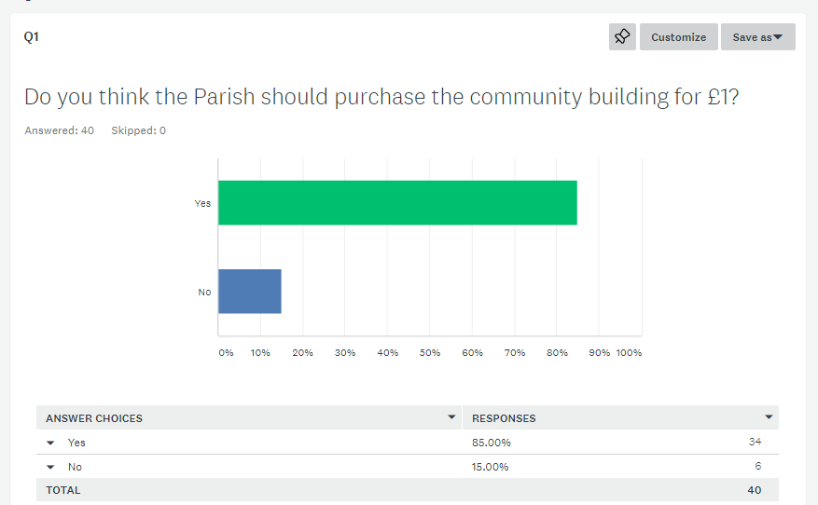
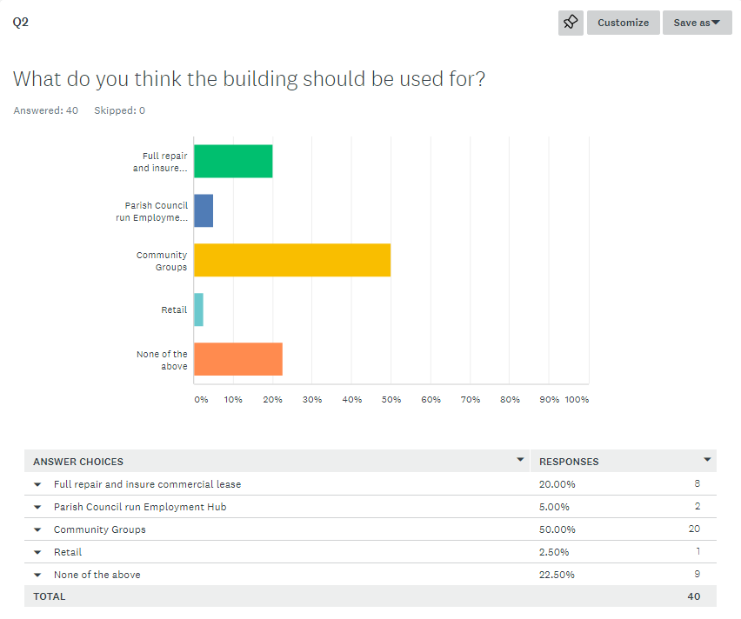
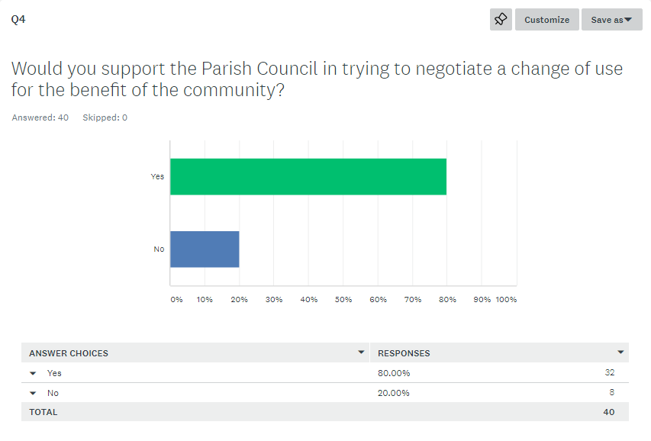
Question 3 Do you have any other suggestions for what the community building could be used for?
CURRENT

Sporting facilities

Retail. Could be a community shop adding something for the top of the village with adequate parking. Shop could be a convenience store, or offering a wider selection of goods. This shop would have the advantage of easy access with parking, signage on main road and along a public footpath from the various campsites.

Employment hub AND community groups. There are over 50 local businesses in Stoke Gabriel (Parish Plan 2008) Complementary health, yoga, meditation etc Preschool? Youth Club Meeting rooms

Community clubs, youth clubs

Village community activities and clubs

Either full repair commercial or community use would be the best options

Gym

Any and all kinds of local community group activities subject to vetting by the local parish council

Any local community village uses

Change of use to a single dwelling/sheltered housing

Clubs, talks, meetings, etc.

Local Housing

Pre-school or school

Nursery Group After School clubs Adult learning groups Rent-a-desk space Fitness Classes Or suitable retail options

As a new Village Hall for the use of the Parish Council and other community groups in the Village

These facilities have benefits for a commercial lease however if there is no local organisation willing to consider a long term let then the commercial lease may be the only viable option. The building has a number of rooms and these could be let to various local organisations either free of charge or at a nominal sum while awaiting a demand that may materialise.

Yes, business use within Class B1, except for public/exhibition hall, which would cut across existing facilities, such as the Schoolroom, Village Hall, Scout Hut,Cricket Club and Football Club, Most of these are struggling with bookings because of Covid

Pre School Group Health facilities, private and NHS Rooms leased short term to individuals or small businesses Exhibitions, eg. tourist information centre related to Stoke Gabriel Rooms leased to small organisations for meetings

I suggest a commercial lease with a 5 year term so that the property could be used for a community project at the end of that term if need be.

With more parking than village hall, any gatherings of local clubs, etc. Hiring for functions (if would not disturb Cavanna homes and surrounds) say not beyond 11.00pm.

Test the market. Then we will know.

Activities that cannot be undertaken at the Village Hall

The cost to the parish would be far too great,so no suggestions.

Community based groups to help support our villagers and outer areas

Nursery and/or Community Hub with visits by CVS/SHDC Planning adviser/SHDC officer for any queries. Parish Clerks office

I’m aware that the village hall is often double booked or clubs need to move out when certain things are going on - eg polling station, panto, art exhibition etc. I also think with more space available of different sizes it offer# more flexible space for more clubs, excercise classes etc

Obviuosly it would be easiest and most cost effective to let it out on a commercial lease and would not require much ongoing management. Of course it might have been nice to have a brand new village hall especially if it had parking for our less mobile residents who cannot walk far. It would also mean people from outside the village could attend paying events more easily and hiring out for events would be easier.

A health hub - therapy room, yoga/fitness studios. There wouldn't be a need for many fixtures and fittings and not much electricity would be used. There are many professional therapists and physical activity instructors that live in the village that would use it. They could benefit from lower rent in return for giving cheaper treatments/classes to the community. Keep it a shared space so that no one is monopolising the space.

An employment hub but sub-contracted by the parish council for someone else to run. If it is to be used for community groups there needs to be a study on whether extra space for these groups is needed and what impact that would have on use of other community spaces in the village.

No because it was a stupid idea to start with.

Q5
Question 5 Any further comments

I don’t think we need another community building.

Sporting facilities will take a time to catch on as there is nothing locally comparable, however once established it will provide a benefit for the health of the local community. The building may well have to be adapted to provide for different sports. I understand that the school is contemplating sporting facilities however the community building is available now whereas the school has not yet progressed the idea.

Community may be reluctant to come up with ideas as this is an additional feature for the village

Many people have asked for this bulding over many years and there have been a number of officila consultations (Parish Plan, Neighbourhood Plan, Cavanna etc) it is the PC's responsibilty and duty to buy this building on behalf of the residents they represent.

I think it should be for the use of villagers as opposed to commercial activity.

Residents would benefit from having a gym in the local community it will befit so many people with staying healthy and this also benefits people’s mental health. I can’t see how running costs could amount to 12k but that wouldn’t take much to cover in membership fees I would happily pay £30 a month to have something like that to use.

I believe the parish council should do everything in its power to secure the use of the hall and in particular look at ways of providing good quality facilities for younger people in the village.

It would be tragic to let this building be wasted.

From the figures given the best case scenario is that the Parish will invest £6001 in order to break even - at worst the Parish could lose £3000 or more per year. We should NOT take over this building which could be another white elephant like the "Burial Ground" and will cost the residents of the Parish a lot of money in the long term. The building was unasked for and unwanted. Cavanna and/or South Hams DC should sort this out. The Parish Council have neither the expertise nor the structure to run this successfully and should NOT get involved.

S106 monies should not be allocated by SHDC, but should reflect what the community needs!

But in regards to the above, this would depend on what the parish council, felt the village needed, and viability of the building. I think it is an asset that the village would be silly not to take on, as i'm sure there are people who could make the most of the building

The existing Village Hall to be handed over to the Village school for their use.

Negotiating a change of use may be necessary however it may be prudent to allow the local organisations a few years to see if they wish to take advantage of the new facilities.

It is regrettable that the Parish Council was not consulted by SHDC regarding the design, size and spec of this building, so is not obliged to take it on. On the face of it the purchase price of £1 seems attractive, but Parishioners would have to cover initial set up costs, rent free period, and likely ongoing losses, through the Precept. I will expand on my comments through the other link provided.

I have experience of working in quite a few shared offices and have seen mixed success. They need to be actively managed to be a success and I fear that the management costs would not be recouped for a building of this size.

Cannot see dimensions of floor plan. If large enough for say badminton or other sport, could a grant or ongoing help be obtained from Sport England or similar to help defray costs.

Suggest the Council should not complete the purchase until the Coronavirus pandemic is over. Thereafter I feel sure a suitable tenant may be found.

Council should buy and then figure out use ie not make buying contingent on establishing use first as owning the building has “option” value

Re answer to no.4 again the cost. If the village hall were to be sold,would the community organisations be prepared to use and finance the new building.E.g increased hire charges etc.

I feel reading the website,leaflet the parish have come across in a negative manner towards the beautiful building. Change is sometimes good and will give future generations good opportunities it’s not about you it’s for the future. I’m disappointed with the lack of drive to grab this and push it forward life is about enjoyment and there will be years and years in this building. It’s new,you gave planning permission for this to happen it’s part of the village embrace it and include it as part of this village

I think the purchase of this building by the Parish Council is an excellent idea and can be used to benefit the community in a variety of ways

Not sure what the benefit of applying for change of use would be

SG have a village hall that is suitable for it needs and more. The village hall is the heart of any village. The report proposed a possible rental opportunity for the centre. This would only Benefit a private company and not the local community with the add financial liabilities of running cost. The claim that the tenant would cover cost that be it may, only during tenancy. If at any point the centre had no tenant cost would be incurred. If use for local community , how would this be funded. At the cost of our current village hall?. It is for this reason I strongly object the any involvement in the new centre. With reference the Question 4 Why would the Parish Council need the negotiate a change of use? The current Usage states D1 with Public use.

I wouldn't like to see it leased out as office space. It would make sense to use it for the village community. A health hub would be my first choice but the school would benefit from more space. 3rd choice - tourist information centre with an art exhibition room.

Communitybuildingstokegabriel@gmail.com responses

For the magnificent sum of £1 you can have a sound, newly-constructed building with all necessary services. If you are unable to identify a use for this building which is of direct benefit to the Stoke Gabriel community and has no significant cost risk, I suggest you should seek a change of use planning authorisation and then lease it on a peppercorn basis to an appropriate organisation for conversion to a low-cost rental home to be available to a person working in the village in a job which is supportive to the community.

Can I suggest that in this interim period before the completion of the building, that the Parish Council advertise a “Call for Expressions of Interest” for companies, groups or individuals who may consider or be interested in renting the Completed building.

This would give some degree of certainty and test the conclusions expressed in the Bettisworth Review document and allow a more informed choice to be made as to whether taking on the building would be an asset or a liability.

Thank you for the opportunity to comment on the possible use of the community building.

The report on the viability of commercial/office use is encouraging. We would support the building being available for small scale office uses. Possibly one of the 3 spaces could be allocated for temporary uses such as a meeting room, short term office use etc, and the other 2 spaces made available to fixed term tenants.

It will be important to strictly control any use of the building to avoid adjoining residents being adversely affected by noise etc.

Dear Councillors,

The Parish Council does not need to get involved with this Community Building. It was not consulted by SHDC regarding design, size and specification of the building and is not obliged to take it on.

Councillors should not be burdened with the management of this building, leaving them to focus on their many other responsibilities.

The permitted uses, now under Class E are ok, apart from use as a Public Hall, as this could adversely affect existing village hiring facilities, such as the Schoolroom, Village Hall, Scout Hut, Cricket Club and Football Club, who are all struggling with bookings because of Covid.

Bettesworths Viability Report suggests the rental that might be achieved will range between £9000 and £12000. The higher figure would be no better than break-even, with annual costs also accessed at £12000

A purchase price of just £1, on the face of it seems attractive, but the Parish Council would have to cover set up costs of £6000, 3 months free rental, and likely ongoing annual losses, all of which would have to be funded through the Precept.

The risk is not worth taking, and it would be best left to Cavanna to find a Community & Land Management body, with the expertise to run such a building.

Thank you for very informative Information on the above.
I feel that it’s best for the council to refuse the offer, the councillors already have enough to sort out and we cannot see any long term gain in purchasing the property.
We have more than enough halls in the village to suit the villagers needs.

Parish Consultation - Thank you for giving the community the opportunity to comment on the new Community Building.
After reading the report from Bettesworths, I believe the Parish Council should purchase the the property and offer the building on a long term rental agreement.

In reply to the leaflet - Public Consultation of Stoke Gabriel Community Employment Building - my comments are:
I think the Parish Council should purchase the Commercial Community Building for the sum of £1.
The building is located in a good position on the site, at the front of the housing estate for easy access and forms a buffer from the road to the residential houses behind.
The Parish Council could use the building as an ancillary village hall for the village. This may be useful since there are going to be more houses and therefore more community activities/venues required.
Also the Parish Council could rent it out for commercial purposes, gaining revenue for the Parish.
It is not large enough to become a replacement building for the village hall, so can only be ancillary to the village hall but at least it will be built with good car parking facilities and so could be useful for village events.

£1 for such a building is an offer too good to refuse. However, even though I live close by, I fear that its use as Community Centre is in danger of splitting the village. To what use it can be put, I know not.

There seems to be a problem with the Parish Council website as I cannot access it to view the details of the proposed building.

I have seen the building in Cavana estate however - from my point of view it could act as an excellent modern communal space for the village. If the space inside allowed I would certainly use it (if costs allowed) at least 3x a week for yoga classes. Flexible internal space would perhaps be the key; temporary dividing walls if people needed smaller separate spaces but allowing the space to be used as a hall too?
A place that can be hired on an hourly rate would be beneficial, the village hall, although not expensive per hour when you consider the whole slot, is expensive if you just use it for an hour and a half as I do.

If someone informs me when the website it back up and running and I can see plans that would be great, I havent grasped the scale of the building/rooms.

My wife and I have recently moved to Stoke Gabriel and therefore have an open and an unbiased outlook.

We both feel this building, no doubt would be an asset if purchased for the £1 suggested.

It is so easily accessible for the community and has the much desired parking facility that this area lacks.

Whether used commercially with a rent income or an additional village Community Building with a small annual contribution from all householders in SG to cover all outgoings and running expenses, this one time opportunity has our vote......

My opinion is: Unless you have an interested party to rent the whole of the building I do not think we should purchase it because running costs and management of the site would make it a millstone around our necks. We would be forever fundraising for it which would take away money and support for other already established village ventures.
My Mothers opinion is: it would be great if Roz could establish a "pop up shop" in the building a couple of days a week in order to support the population at the top of the village.

In our opinion, taking account of the design of the building, the village would benefit most from a medical facility. A Community nurse/clinic and a dentist or even a part-time GP. A possible example we are familiar with might be Bishopsteignton.

The advantages of or reasons for having this facility in Stoke Gabriel could be:
- Reducing the number of journeys by patients to Paignton or Totnes, along totally inadequate roads (in reality country lanes).
- Fewer journeys means less environmental impact.
- Stoke Gabriel probably has an older age profile, increasing demand for these services.
- Having this local facility would make immunisation/vaccinations (flu, covid, etc.) more accessible, including for school children. It may even encourage more local people to be vaccinated.
- Reduce the number of journeys made by visiting Community nurses from Torbay or Totnes. For example, I had to have a dressing changed after an operation and the nurse had to come from Newton Abbot. I could have walked across the road and had the same treatment at a Community clinic.

I am sure other residents could think of many more reasons why this might be a good idea.

Access to the survey is extremely difficult. Many of the people whose opinions are being sought will be unable to access it and could well give up trying after half an hour from sheer frustration.
It should also be noted that many of the older residents have no, or at best limited, access to the net.
Additionally, some residents most affected by the building - for example those who live exactly opposite it on Paignton Road did not receive leaflets.
This whole project was ill conceived and is now being poorly executed.
If we are being asked to shell out £6000 for setting the place up followed by an annual subsidy of up to £3000, the consultation process should have been more accessible and more effectively carried out.

I wanted to share a community health and activity centre which we used when living in Hemyock: http://bhlac.org.uk/ . I don't know if it would be viable for the community building in SG but it certainly was a marvellous provision up in Hemyock. It had lots of functions for the community - elderly, families, carers etc but also offered therapies, services, classes and groups on a regular basis. The space could also be rented by the community for events etc. This was a not-for-profit chatity so may not be the format you're looking for but it really did enhance the village of Hemyock and its provision for some of the more vulnerable groups.

Hope this is a useful suggestion - you can get more info on the offering under the different tabs of the website.

Dear Parish Councillors
Thank you all for sending out the leaflet and putting all the information on the website.
I have concerns about buying this building as the cost of its upkeep will fall on the Parish and these costs will be ongoing and could be quite high.
There is really sufficient venues with the village hall, School Rooms , Scout hut and the football club offering spaces for use.
There is a change of work patterns since CoVid and many people are working from home and finding this works for them. This means people will not be so keen to take on the cost of renting work premises.
With these things in mind I would definitely be against buying the commercial building from Cavanna.

Thank you for the informative documents made available on the Parish Council website which I have read with interest. I have a few further questions, if I may.

- I have not been able to find an estimate of annual running costs for the building, other than one (for £9,000) relating to a letting scheme involving multiple tenants as a work hub. In other words, if the PC takes it on, what is the minimum rental income needed to break even? Even if the building stood empty for a while, presumably the village would have to cover buildings insurance, background heating, water and sewerage rates, maintenance etc.
- The report from Bettesworth seems (to my surprise) encouraging about rental prospects, although the post-Covid outlook must be less certain (but I note it was prepared in August so must have taken account of that). What other local examples of workhub/rural office space are there I wonder? How for example have the units at Berry Pomeroy fared?
- I gather from informal conversations with a Parish Councillor that Stoke Gabriel Primary School has not expressed any interest in using the space, which I find a little surprising, especially given the current need for greater space in order to distance pupils – but to be honest I do not have close knowledge of the school and theirs is the informed view. Also, that any move to relocate the Village Hall activities to this new building (thus freeing the Village Hall for school use?) would be unpopular with users – despite the increased parking spaces? Nor I gather is there any particular demand for work units from residents, for the present at least. Am I correct in my understanding of these responses?
- I am assuming that feelers have been put out to local charities and voluntary organisations to see whether this space could be attractive to them, although of course charitable funding has been badly hit and a lower rent might have to be on offer. Has the Devon Community Foundation been contacted to see who might have an interest?
- The question has to be: what activities does the village not currently provide which this building would facilitate, or which existing activities could be better served? There is a pre-school, and the Village Hall caters for clubs and societies a well as village meetings. We don’t have a library or pharmacy – but do we need them and who would run them/pay for them? A community café combined with library/play group/sports hall sounds lovely but there are the same problems of underwriting the running costs, and in the case of a café might impact on existing businesses. It will be interesting to see what the new residents feel they would like to see in the village which it does not already have – within reason, of course.
- I am not clear what happens if the PC does not take up the offer. What is the status of the Community and Employment Management Body and how is it funded?
- I note that Cavanna are doing (or were proposing) a similar development at Blackawton which also involves a Community and Employment Building. Has anyone compared notes with the Parish Council there?

My feeling is that while taking on the building is a big responsibility, it would be a shame to turn it down only to regret it in a few years’ time, when activities and needs in the village may have changed. I can appreciate that to many, the location of the new building seems rather ‘out of town’ compared to the Village Hall and School, but the village boundary has already expanded in a number of directions because of recent development and its centre of gravity has shifted as a result; and by definition there will be a new population on its doorstep. The availability of car parking mitigates to an extent the building’s location although whether residents would want to drive to activities is another matter. Of course, to take on a costly white elephant would be imprudent, which is why it is essential to have a firm idea of the base running costs. If the Parish Council takes it on and in a few years finds it is a drain on resources will it be free to sell it or grant a long lease, or will conditions be attached which prevent this?

We do need to take an imaginative look ahead at how life in the village may evolve: not an easy task But this consultation is an excellent way to invite some lateral thinking and I will be very interested to see what others suggest.

This is clearly an important decision and I wish the Parish Council well in its deliberations.

Dear Parish Councillors,
I have been unable to access the Surveymonkey survey despite trying many times.
The idea of a new community building for Stoke Gabriel came out of the initial consultation for the Parish Plan. Consultations for the Neighbourhood Plan confirmed the wish of residents to have this facility. During the planning application process there was overwhelming support with many suggestions for use coming forward - has the PC kept records of these? Residents were again consulted by the NP Steering Group when the building was being designed. So it's clear many people have been involved over the years in getting a building we need, to meet uses specified by us, to this stage.
Our parish has missed out on community facilities when housing sites were allocated in 2009, unlike others which got new village halls and/or schools.We also missed out on the provision of a village carpark required at the Blue Cedar Homes site.
Therefore it is the duty of the Parish Council to take on responsibility for this building.
Once this decision has been made it is essential the PC continues to consult with all parishioners. Consultation by the PC in the past has been patchy and with a narrow focus. For instance, I'm aware local therapists were consulted at one point, but who else? It is essential to establish uses of the building to enable a balance between community and business use to ensure a financially secure future for this building.There are many aspects, some of which I've detailed at this stage below.
The new Class E use, which replaces the B1 & D1 in the original consent, appears to cover just about anything we would want to use the building for. We should not be put off by the current layout. Should uses for the building become established at some stage in the future which require a different layout, it can be changed.
The PC will need to establish a management group which should include users of the building, both business and commmunity, and whoever takes day to day care of the building. Those living close to the building who will be most affected should also be represented - maybe whoever chairs the Kings Orchard Residents Association? Continued support from local residents is essential and they may well be the source of most uses. I think the building has the potential to be extremely popular for groups wishing to meet at this end of the village, especially among individuals who find the hilly access to the village hall difficult.
The PC/Management Group will need to adopt a number of policies as to use. These should including one on charges, which should prioritise community use and local business use. Another should adopt the Sustainable Transport Hierarchy to ensure walking/cycling to the building are required where possible so access by car is strongly discouraged. Bike racks, Blue Badge space, EV charging point - all must be considered. The PC will need to be realistic as to the input required into the provision of this facility but also has to encourage creative thinking. There is a huge amount of support and information available from Devon Communities Together. https://www.devoncommunities.org.uk
I urge the PC to register interest for DCC's Solar Together Scheme, which must be done by Oct. 6th. Solar panels would reduce running costs of the building.
I do hope that the PC collates all responses and makes these available to encourage further community input. I suggest a report summarising responses received which mut be widely available.

Hi,

I'd like to respond from two perspectives.

1) As a member of the community: As you know, the idea of a new community building for Stoke Gabriel came out of the initial consultation for the Parish Plan and many people have been involved over the years in getting it to this stage. It is part of the Neighbourhood Plan. It was again flagged up by parishioners as something that was needed at the Cavanna consultation.
Stoke Gabriel residents were again consulted by the neighbourhood plan team when the building was being designed. So we know that this building is something that has been asked for by the people of Stoke Gabriel parish and we know that it has been designed with our unique needs in mind.
Therefore, it is the duty of the Parish Council which serves the residents of this parish to take responsibility for the community building by first buying it for £1 and then establishing a management group which may or may not be made up of me,bers of the PC.

2)From a personal perspective: I was consulted as a local self-employed business at the planning stage in relation to the use of the community building by complementary health practitioners in Stoke Gabriel. This is something I may well be interested in (although my circumstances have changed since the idea was first proposed) and I am aware of a number of other therapists who may wish to use the space provided. We have a wealth of small businesses in Stoke Gabriel - the Parish Plan survey showed that over 50 businesses were running in the parish, and with the increase in dwellings and population since then, I would guess that the number is somewhat higher now.

So, I think that the Parish Council should buy the building and has a duty to do so,

I believe that the council should acquire this new building for just £1. It will be an asset to the village and it unusually in offering so many parking spaces for a building of that size. Most offices we have rented have been unfurnished as most businesses have their own ideas on how to furnish the office. I would also be interested to find out the breakdown of £12K annual costs, which seems excessive.

Good afternoon,

Firstly, thank you for giving us the opportunity to have our say. It looks as though this will be a great building once it is in use, which I will be pleased to see after an extended completion date due to COVID-19.

I actually work in Construction myself and like many others, since March have worked from the confines of my bedroom with a make shift work from home set up. My office was closed for an extended period of time and it has now only just opened up to its employees to work from with new regulations in place. I’ll be working from the office in Exeter just 1 day a week, then the rest of my working week I will be working from home. It definitely has it’s benefits. However, it also comes with its challenges. I like many others, have a family and home commitments which regularly interrupt and distract from my usual working day.

My suggestion of the use of this building would be to use this building as an office / work space for people like me who do work from home, but also would massively benefit from having a quiet, separate designated work space to work from for the day.

I actually live on the house directly opposite this building (16 Ford Way) and would feel happy to help co-manage the operation of it’s day to day with the parish council.

I have had a look at the plans, and it appears the layout has been perfectly set out with the intention of being an office type environment.

Regulations could be put in place within the community building, such as:
- Sign in book (also to help track and trace)
- Isolated desks to help socially distance
- No cutlery, cups etc to help stop the spread of any contamination whilst also maintaining its operation without filling the sink with dirty dishes.
- A donation pot could be set up for those who wish to donate to use the space

The space could still remain flexible with these original intentions, with other use applied easily by simply moving any furniture which is in there.

I think the key benefit here is giving the environment to a lot of local professionals who do not have the luxury of their own home separate office. I believe this building has the opportunity to create more engagement within its community.

I look forward to hearing your thoughts and would welcome a call to discuss.

Dear Councillors

I am most excited about the potential of this venue.

As a local music teacher it would be so useful. I only heard about this by word of mouth. Was there a consultation?

Will there be a piano?
I was sent a link to access the Surveymonkey survey but couldn't make it work.

How accessible will it be?

Special rates to encourage and prioritise local use?

Dear Parish Councillors ,
Thank you for organising this consultation .
We have studied the plans for the building on offer to the Parish and think that on balance it would be a good idea to purchase it for the village - providing that it could be sold in years to come, albeit with the restriction that it would be for local business use .
We appreciate that it’s use should not undermine the use ( and therefore income ) of other existing village facilities and therefore we support the idea of letting the whole building for business use, as it would bring in a useful , hassle free , assured ,regular income for the village.
If this could be done on a shortish lease ,then the situation could be reviewed once life returns to a more normal pattern, and if it turned out to be a liability, consideration could be given to selling the building .
We hope these comments are supportive to the Parish Councillors .

