Highways and Traffic Management
Devon Highways
Great Moor House
Bittern Road
Exeter
EX2 7NL
https://www.devon.gov.uk/roadsandtransport/

ORD 2103820 Aish/ Stoke Gabriel
Drainage Works Lembury Road to Ningham Cross

Monday 26th September 2022

Dear Sir / Madam.

This letter is to give you some further information about the drainage works we will shortly be starting between Lembury Road and Ningham Cross in Aish.

Due to the nature of the works a road closure is required and the diversionary route for traffic will signposted and advance signs will also be placed on the Highway. Drivers with local knowledge will be able to use alternative side roads but these will not be publicly advertised for safety.

I apologise in advance for any inconvenience caused, including noise. We will endeavour to keep all disruption to a minimum. Emergency access will be maintained and access for residents.

The planned on-site working hours will be Monday 10th October until Friday 21st October, although works may be extended if issues arise.

Our planned programme for the delivery of the work is:

- Cleaning and cutting back of vegetation to access the drainage throughout the site.
- Replacement of various lengths of drainage pipes and covers throughout the site at six different points.
- Installation of side haunches to aid water runoff into the new drainage and or local easements.
- Installation of verge marker where appropriate.

Please see a map below of the extent of the works.

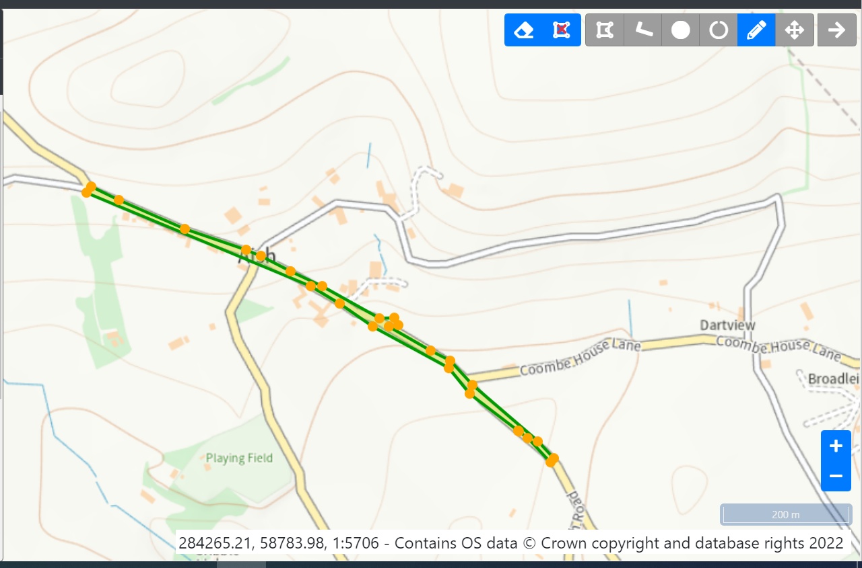

Information will be posted on our Devon Alerts social media and can be found here

https://www.facebook.com/DevonAlert

@DevonAlerts

Thank you for your patience and understanding while we are carrying out these works.
Should you have any questions please contact me at Phil.Durrant@devon.gov.uk and I will do my best to try to help.

Regards
Phil Durrant
Customer Liaison Officer

