Stoke Gabriel Parish Council

Minutes from the Parish Council Meeting held on 28th November 2022 at 7pm
Present: Cllrs Tully (Chair), Harris, Collings, Blood, Bridge, Callaghan, District Councillor Rowe, 5 members of the public, Phil Bolt (Tree Warden), Rob Barber (Locum Parish Clerk)
22/11/01 Apologies: Cllrs King, Patch and Fletcher, County Councillor Hawkins, District Councillor Bastone.
All apologies were approved.
22/11/02 Declaration of Interests - None
22/11/03 Dispensation Requests - None
Standing Orders were suspended
22/11/04 Public Participation
The Tree Warden gave an update on the trees in Hoyle Copse and the Orchard:7 trees with ash die back along the path have been felled and 6 of the “yellow spot” ash die back trees have also been felled by the volunteers.
It was agreed that the Tree Warden be authorised to purchase a winch for around £150 to assist with tree felling.
The Tree Warden also stated that the contractor for the accessibility path in the Orchard was awaiting formal authorisation before he could start work.
ACTION: The Clerk to authorise the contractor.
22/11/05 Councillor Reports
District Cllr Rowe
The report is posted on the Parish Council Website
It was noted that Cllr Rowe has contributed £230 towards the cost of the new gate in the Orchard. The monies have come from a Sustainable Community Locality Fund application.
It was noted that the Verger will report to Council on the number of empty plots remaining in the Church cemetery.
It was noted that Mike Stott will place an article in the Church magazine to seek another burial plot in the Parish.
Standing Orders were reinstated

22/11/06 Minutes from Previous Meeting
The minutes from the Stoke Gabriel Parish Council Meeting held on 24th October 2022 were signed as a correct record.
22/11/07: Matters arising from previous meeting minutes.
There were no matters arising.
22/11/08: Financial Matters
- Cllr Collings gave an update on on-line banking, stating that it is now in place.
Cllr Tully offered thanks to Cllrs Collings and King for their hard work.
- It was agreed to purchase the financial software package Scribe
- The list of payments to be made (cheques and on-line payments) were all agreed, and cheques signed. On-line payments will be transacted after the meeting.

It was noted that future payment by Council will principally be via on-line and that invoices need to contain BACS details. Clerk to oversee.
- The Terms of Reference of the Finance and General Purposes Committee were reviewed as follows:
  - It was agreed to increase the Membership to five
  - It was agreed to change the frequency of the internal audit from quarterly to annually
  - It was agreed to transfer the “Personnel Matters” to the Staffing Committee
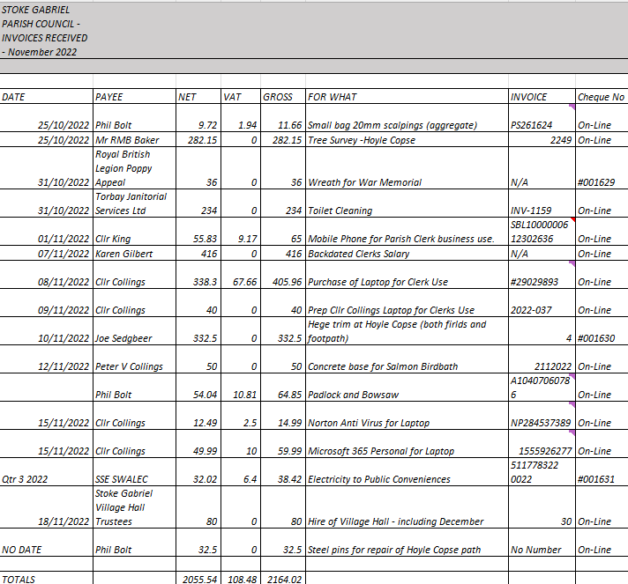
22/11/09: Clerk’s Report
Clerk’s Report 28th November 2022
Clerks Actions from October 24th Meeting
1. Cavanna Hedge Cut
Andy Darnes at Cavanna Homes has committed to the Cavanna management company cutting the hedge.
2. Hedge cutting during hours of darkness
Director at White Hills Country Park believes their hedges were cut on the evening in question and has provided contact details of the primary contractor.
It was noted that no further steps be taken
3. Refuse Collection Update:
Added to January Draft Agenda as actioned.
4. Clerk to assist Cllr Bridge with VAS recommendation for November Council meeting.
DALC were approached and the guidance given was copied to Cllr Bridge
Harberton PC have been approached and have sent a detailed document and advised that this project has taken over a year and device not yet installed.
I have been advised by Cllrs Collings and King that this project is not a priority within the Clerks allotted hours.
Please also see section 22/11/11
5. Stile at the Narrows
Enquiry reference W221551174 relating to Public Right of Way (Public Right of Way) was reported on 04 Nov 2022, an assessment for this report was completed on 16 Nov 2022.
The officer entered the following comments:
I have instructed a contractor to investigate, and resolve if safe to do so; otherwise, to report back to me.
After this Paul McFadden has asked Lisa Edmunds to determine who the owner of the boundary bank is to enact repairs to the bank before the stile is repaired.
We are now waiting further progress.
It was noted that the “bank” at the stile may be owned by Cavanna Homes.
6. Steps at Aish
Enquiry reference W221551184 relating to Public Right of Way (Public Right of Way) was reported on 04 Nov 2022
An assessment for this report was completed on 16 Nov 2022.
The officer entered the following comments:
Contractor instructed to replace these steps asap.
7. Round House Planning Application
As actioned, an extension to the comment’s deadline was agreed with the Planning Officer (and a further two weeks agreed) and a site meeting was agreed with the agent and applicant for 22nd November.
Relevant update from Clerk’s report 24th October
- VAT claim for the previous 4 years
Clerk reported to the Finance Committee that HMRC advice is to either wait for handwritten VAT126 form to be processed or to resubmit online. This was reported at the Finance Committee Meeting.
It was agreed to wait for the handwritten form to be processed.
- HMRC Payroll
The HMRC payroll system is not as user friendly as reported by the Clerk at the previous meeting as there is now a requirement to link free payroll software to the HMRC system. An attempt to access the Councils account have not been successful to date. The Clerk would like to propose use of SHDC payroll system at a cost of £100 per year. This will require consideration by the Finance or Staffing Committee to proceed. For transparency Cllr King is in favour of the HMRC system.
It was noted that Cllr Rowe supports the use of the SHDC system.

Other Clerk activity to report
- Materials dumped in Fleet Mill Lane by Devon Highways. Clerk working with Lisa Edmunds to resolve.
- Clerk urging response from Patrick Whymer on issue over Cavanna permissive footpath and concerns over its future.

It was noted that Patrick Whymer has responded.

ACTION: Clerk to circulate the response.

- Lady Stumbled on paved area at Rydon Acres. Cllrs King and Rowe assisting the Clerk.

It was noted that the ownership of the piece of land needs to be understood in order to make progress on resolving this issue.

ACTION: Clerk to identify owner.

- Finance Committee meeting held, and minutes issued.
- Bird bath insured and Wassail insurance checked.

ACTION: Clerk to seek formal notification of details of Wassail and pass onto the Council’s insurance.

- At Cllr Harris request the Clerk has requested a meeting with Planning Management to encourage clearing the planning enforcement backlog.
Main area of focus for December will be budget and precept.
22/11/10 Planning Matters
The following applications were discussed, and these Comments will be submitted to Development Management (South Hams and West Devon) for consideration.
- 3350/22/CLE

No comments

- 3612/22/CCN

No comments

- 1999/22/HHO Stoke Court

The Council are concerned that as this property is within the Conservation Area the proposal to demolish the existing chimney stack and replace it by the installation of twin metal (steel) wall flue system that extends above the adjoining roof:

3.1 Will not comply with Policy Dev 21.3 – Designated Heritage Assets
6.63 – the proposal will not preserve or enhance the area by showing respect and compatibility.

3.2 It would be possible to rebuild the chimney and hide the twin metal (steel) flue system within the chimney which would preserve the character of the property within the conservation area.

.33 The proposal just to install externally the twin metal (streel) flue is out of keeping and the shiny appearance will detract from the character of the conservation area.

Recommendation is for refusal

- 3623/22/TPO

No comments

- 3524/22/CLE

The Council would like further clarification on the following points which relate to the application:

5.1 There is a previous application reference 52/0829/06/F which is referred to on plans with the application.
Are the works shown on these plans also included within the current application as being either started or completed?

5.2 The application includes planning approval to application 52/1523/13/F but this is not mentioned in the application form?
Are the works detailed on this application also to be part of the current approval process?

5.3 The application form mentions planning reference 52/0441/10/F
The site location plan for this application differs from the one submitted as part of the current application?

5.4 A Section 106 agreement was entered into as part of application. How does this relate to the current application and as such what is the current requirements for parking for the property and the location of the required parking spaces?

5.5 Pre app planning advice was provided for this application, and it would be helpful if the Council had a copy of this to understand exactly what works and agreements in relation to all the applications the current application relates to.

At present the Council requires further clarification of the above comments before a final decision can be made.

- 3057/21/FUL – The Round House – (Resubmission of 3863/20/FUL)

The Parish Council have held a site meeting with the applicant and his agent.

Arising from that meeting the applicant is prepared to:

1 Accept a condition on the approval restricting the use of the building solely for the purposes of woodland management and the uses shown on the plans accompanying the application. No residential use either permanent or temporary is to be allowed within the property.
2 The internal walls of the 3 open bays of the proposed property will be painted to match the proposed external wooden cladding on the doors to the tool store

The Parish Council have concerns about the height and design of the roof. The original design in application 3863/20/Full was for a shallower pitch roof sloping from back to front.

The current design is for a double height roof where the ridge is at 7M with the eaves of 2.8M, a difference of 3.2M although the submitted plans show the ridge to be 3.12m above the eaves height?

The Parish Council would prefer the roof to adopt a shallower profile and recognise that if solar panels were to be installed, then the roof line should be reversed from the designed shown in application 3863/20/FUL ie sloping from front to back to allow the roof to have a southerly aspect. The upstand at the front of the roof above the openings of the building can be finished in wooden cladding to match the finish on the exterior of the building.

Although solar panels are mentioned on the Design and Access Statement no details of these are shown on the accompanying plans.

These comments reflect those of Amanda Urmson the Council’s Specialist – Natural Environment in her report dated 28th September 2021 which the applicant has included as part of the application, However the Parish Council points out that these comments relate to a “modest single storey building” and not the double height one which is now proposed.

22/11/11: VAS Project Update
It was agreed that the Clerk work additional hours on this project.
First task will be to scope the size of task and how to resource it from a man hours perspective.
22/11/12: Community Building Update
Cllr Harris informed Council that the lawyers have been instructed and that money laundering checks have been completed. Formal instruction to the letting agent have also been signed.
It was noted that the address to be used in documentation is the normal Parish Council address.
It was noted that the Council does not have a seal.
22/11/13: Grass Cutting
In Cllr Kings absence it was noted that the weather has been too wet for the final cut of the year.
There is no update on a 12-month contract with Hatch’s. This will need to be an agenda item at the January Council Meeting.
22/11/14 Community Field
It was agreed to accept the quote from Woodland and Countryside Services for the pollarding of an ash tree in the Community Field hedgerow.
ACTION: Clerk to authorise this work.
22/11/15: CCTV
It was agreed that the Council will not spend further monies on the CCTV.
It was agreed that that the Council will ask the other stakeholders in the area of the CCTV to buy the current facility from the Council.
ACTION: Cllr Collings to approach the River Shack, SGBA and the landowner with a view to selling the CCTV facility.

22/11/15 Hoyle Copse
- It was agreed to accept the quote from Hi Line for felling trees with ash die back.
It was noted that there seems to be a discrepancy with VAT on this quote which needs to be understood and corrected before the work is authorised.
ACTION: Clerk to understand the VAT issue then authorise the contractor.
- It was noted that it is too late to sow wildflower seeds this year.
It was agreed to pass this agenda item to the Finance Committee for consideration for budget submission to Council.

22/10/16 Exclusion of Press and Public
The Council resolved that in accordance with Paragraph 1 (2) of The Public Bodies (Admission to Meetings) Act 1960, the press and public be excluded from the meeting during consideration of the agenda item 14a owing to the confidential nature of the business to be transacted and the public interest would not be served in disclosing that information.
22/10/17 Incident Report
This was discussed as part of the Clerk’s report

Date/time of next meeting
7pm Monday 30th January 2023

Meeting Closed at 21:00

