Stoke Gabriel Parish Council

Minutes from the Extraordinary Parish Council Meeting held on 9th January 2023 at 7pm
Present: Cllrs Tully (Chair), Harris, King, Blood, Bridge, one member of the public, Rob Barber (Locum Parish Clerk)
23/9.1/01 Apologies: Cllrs Collings, Callaghan, Patch, and Fletcher.
All apologies were approved.
23/9.1/02 Declaration of Interests – Cllr Harris declared an interest in Planning Item 4 (3435/22/ARM)
23/9.1/03 Dispensation Requests - None
Standing Orders were suspended
23/9.1/04 Public Participation
A member of the public gave a detailed account of his objection to Planning Item 3787/22/HHO.
Standing Orders were reinstated
23/9.1/05 Planning
5 | Reference | 3787/22/HHO
 | Proposal | Householder application for proposed landscaping to rear garden and proposed secure car port to Northeast Corner (Retrospective)
 | Site Address | Marians Maples, Vicarage Close, Stoke Gabriel, TQ9 6QT
 | Comments Required by | Extension granted until 10th January 2023
 | Decision of Council | OBJECT

The Parish Council comments can be viewed on the South Hams District Council Planning Portal.
1 | Reference | 4110/22/HHO
 | Proposal | Householder application for additional ground floor window
 | Site Address | Gabriel Lodge, Vicarage Close, Stoke Gabriel TQ9 6QT
 | Comments Required by | 19th January 2023
 | Decision of Council | SUPPORT

2 | Reference | 4153/22/HHO
 | Proposal | Householder Application for proposed replacement and small deck extension of balcony
 | Site Address | Pool Cottage, Mill Hill, Stoke Gabriel, TQ9 6RD
 | Comments Required by | 19th January 2023
 | Decision of Council | OBJECT

The Parish Council comments can be viewed on the South Hams District Council Planning Portal.
3 | Reference | 3690/22/HHO
 | Proposal | Householder application for retention of outbuilding and pergola (retrospective)
 | Site Address | 3 Rowes Farm Barns, Aish Road, Stoke Gabriel, TQ9 6RT
 | Comments Required by | 22 December 2022 - Extension requested but not yet granted.
 | Decision of Council | SUPPORT with comment that not to be used for residential accommodation.

Councillor Harris left the Meeting Room
4 | Reference | 3435/22/ARM
 | Proposal | Application for approval of reserved matters following outline approval reference 3138/17/OPA relating to appearance landscaping, layout and scale of 9 houses
 | Site Address | Land at Four Cross Paignton Road, Stoke Gabriel
 | Comments Required by | Extension granted to 10th January 2023
 | Decision of Council | Parish Council unable to comment as mix of housing proposed is not supported by the Principal Planning Officer

The Parish Council comments can be viewed on the South Hams District Council Planning Portal.
Councillor Harris returned to the Meeting Room.
23/9.1/06 To agree or otherwise use of S111 Monies to show appreciation to Hoyle Copse volunteers for their work.
It was agreed to use S111 Monies (see payment below)
23/9.1/07 To approve or otherwise the payment of the invoices and expense claims below.
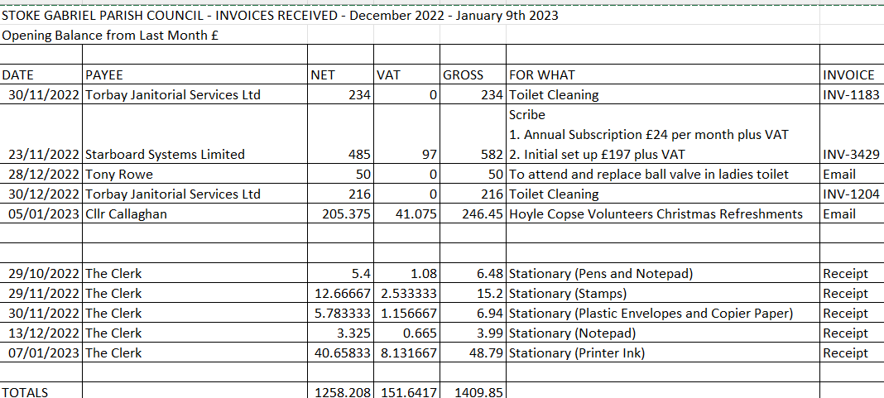
All payments were approved.
Date and time of next meeting: There will be an Extraordinary Council Meeting on Friday 13th January 2023 at 7pm to approve the appointment of a permanent Clerk to the Parish Council.
The Meeting closed at 7.58pm
Rob Barber
Locum Clerk to Stoke Gabriel Parish Council

