STOKE GABRIEL PARISH COUNCIL

The regular meeting of Stoke Gabriel Parish council will be held on MONDAY 27th FEBRUARY 2023 at 7pm in the Village Hall, Stoke Gabriel
All members are summoned to attend for the purpose of transacting the following business. Members of the Public and Press are welcome to attend.
AGENDA
1. Apologies - To receive and approve apologies for absence
2. Declaration of Interests
3. To approve any dispensation requests.
The Council will adjourn for the following business.

4. Public Participation - A total period of 10 Minutes will be allowed for members of the Public to ask questions or make any brief comment regarding the work of the Council or items on the agenda.

5. To note County and District Councillor reports

The Council will convene to conduct the following business.
6.Minutes of the Previous Meeting
To consider and amend as agreed by the Council (if required) & approve the minutes of the Full Council meeting held on 30th January 2023

7. Matters arising from the previous meeting minutes

8. Financial matters
8.1 To agree or otherwise payments of invoices and Clerk’s expenses as recommended by the Finance Committee

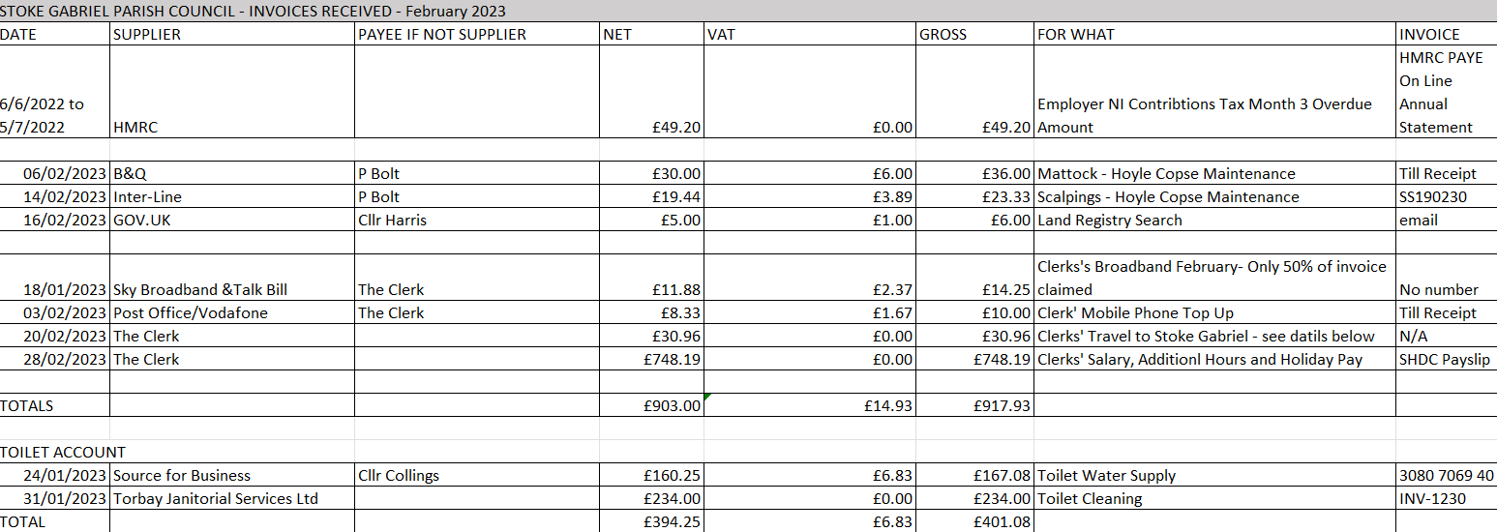

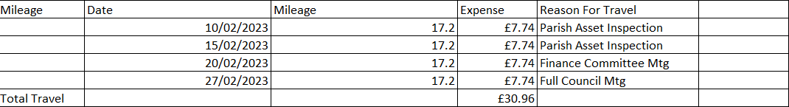

Further Invoices received after the Finance Committee Meeting will be added to this list for consideration by Council.

8.2 To receive status of HMRC Payments and returns (Clerk)
8.3 To receive the status of the VAT return (Clerk)
8.4 To receive the Quarterly Report and Bank Reconciliation (Clerk)
8.5 To receive the Quarterly Internal Audit findings.
8.6 To agree or otherwise the selection of Internal Auditor as recommended by the Finance Committee
8.7 To receive the update on the Parish Asset Register update.
8.8 To receive and agree or otherwise the recommendation of the Finance Committee regarding cyber-attack and data protection insurance.

9. Clerks Report – To note the Clerk’s Report to be posted on the Parish Council Website
10. Planning Matters
To receive recommendations from Planning Working Party
11. Local Government Election Timetable of Proceedings for Thursday 4th May 2023
For Council to note the following upcoming events:
- Publication of Notice of Election - Thursday 23 March 2023
- Start of Nomination Process – 10am Thursday 23rd March 2023
12. King’s Coronation Celebrations
- For Council to receive update on King’s Coronation celebrations
- For Council to agree or otherwise next steps in the preparations.
13. Community Building

To receive update from Cllr Harris
14. Delegation of Powers to the Committees
- For Council to agree to otherwise to the Finance Committee having delegated powers.
  - For Council to agree or otherwise next steps
- For Council to agree or otherwise to the Staffing Committee to having delegated powers.
  - For Council to agree or otherwise next steps
- For Council to agree or otherwise to the Planning committee (when formed) to having delegated powers.
  - For Council to agree or otherwise next steps
15. Exclusion of Press and Public
The Council is invited to RESOLVE that in accordance with Paragraph 1 (2) of The Public Bodies. (Admission to Meetings) Act 1960, the press and public be excluded from the meeting during consideration of the agenda item 1 o6wing to the confidential nature of the business to be transacted and that the public interest would not be served in disclosing that information.
PART TWO

16.For Council to receive update on Hoyle Copse notice board.
For Council to agree or otherwise next steps.

DATE OF NEXT MEETING – 27th March 2023

Rob Barber –Rob Barber, Clerk to Stoke Gabriel Parish Council

