Stoke Gabriel Parish Council
Minutes from the Parish Council Meeting held on 27th February 2023 at 7pm
Present: Cllrs Tully (Chair), Harris, Callaghan, Collings, Blood, Bridge, District Councillor Rowe, County Councillor Hawkins 2 members of the Public, Rob Barber (Parish Clerk)
23/02/01 Apologies: Cllrs Patch, Fletcher, King and Bastone
All apologies were approved.
23/02/02 Declaration of Interests - None
23/02/03 Dispensation Requests - None
Standing Orders were suspended.
23/02/04 Public Participation
In a response to a request from the Clerk, The Church Verger brought the Red Ensign flag to the Meeting by way of confirming its condition as part the annual Parish Asset inspection.
The Verger also requested assistance in determining which is the correct day for this flag to be flown from the church.
Action: The Clerk to determine which day to fly the flag.
One of the applicants for the tenancy of the Community Employment building gave a verbal presentation in support of her application and handed the Councillors and the Clerk a letter covering the same topic.
Cllr Harris thanked the member of the public and specifically requested that she present her business plan to the Letting Agent.
23/02/05 Councillor Reports
District Cllr Rowe
Cllr Rowe asked of the Council as to whether they were planning some “open time” for Parishioners to find out what it is like to be a Councillor and to generally promote candidates for the posts of Councillor in the upcoming elections.
Cllr Bridge suggested some wording to be posted on the Facebook page which would need to be posted by Cllr Patch encouraging members of the public to put themselves forward for nomination.
Displaying posters in the Post Office and the two Pubs was also discussed.
Action: The Clerk to send the suggested wording to Cllr Patch for placing on the Good Neighbours Facebook page.
Cllr Blood expressed a concern that the requirement for photo ID being required as part of the election requirements did not seem to be widely known.
it was noted that this requirement had previously been circulated to Councillors and for posting.
It was noted that the Clerk is attending a Devon Association of Local Councils course “Preparing for Elections” on 1st March.
Cllr Rowe stated that the refuse collection process is going well, and Cllr Tully added that SHDC had performed well in doing so.
The report is posted on the Parish Council Website
District Cllr Bastone
Cllr Bastone had offered his apologies.
The report is posted on the Parish Council Website
County Councillor Hawkins
Cllr Hawkins reported that he had not managed to attend the most recent Brixham Road closure meeting but understood all is ok.
Cllr Tully commented that Waddeton is busier than normal but not as busy it was thought it may be.
Cllr Hawkins said that the “temporary parking” near the gas box at Four Crosses it tb removed and the grass reseeded.
Cllr Bridge expressed a concern that car headlights after dark are reflecting off the surface of the gas box and causing a safety hazard.
Cllr Hawkins said he would mention this concern to the Highways Officer.
Cllr Hawkins reported that Devon County Council have set their budget for the upcoming year, 70% of the budget is allocated to Care, with Child Care increasing by 18.4% and Adult Care by 9%.
Cllr Harris raised a question as to when the new waiting restrictions in the village would be in effect, Cllr Hawkins replied saying that this would be as soon as the paperwork could be processed.
Standing Orders were reinstated.
23/02/06 Minutes from Previous Meeting
The minutes from the Stoke Gabriel Parish Council Meeting held on 30th January 2023 were signed as a correct record.
23/02/07: Matters arising from previous meeting minutes.
There were no matters raised.

23/02/08: Financial Matters
8.1The list of payments to be made as listed below were all agreed.
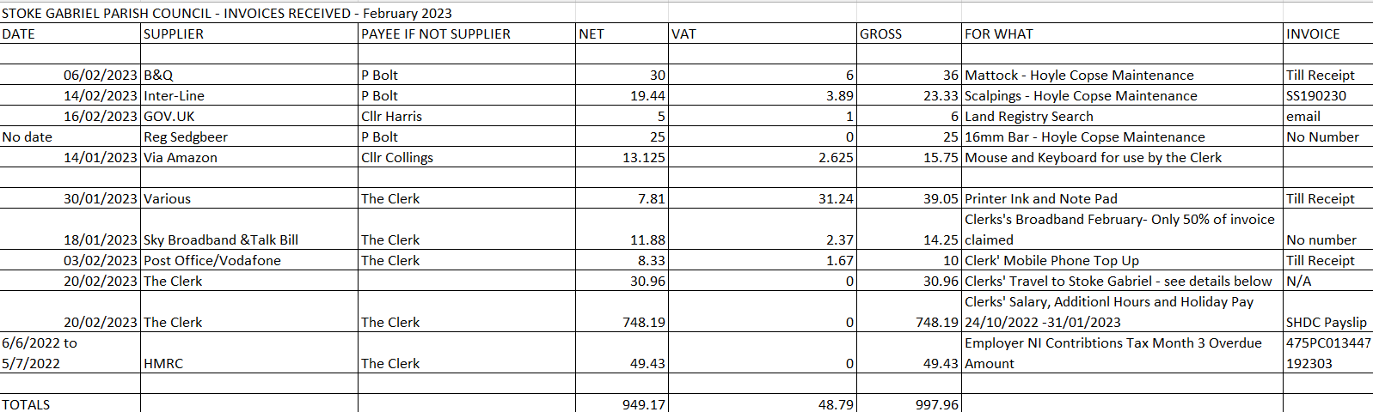

  - To receive status of HMRC payments and returns.
The Clerk reported that the payment for March 2022 and the HMRC returns for October, November and December 2022 made by SHDC Payroll will clear all concerns with National Insurance Contributions.
  - To receive the status of the VAT return
The Clerk reported that the return has not been received and that the Finance Committee recommendation is to wait for the return rather than submit a duplicate on-line return.

  - To receive the Quarterly Report and Bank Reconciliation
The Clerk circulated a report from the new finance software (Scribe) detailing spend to date against the budget set for this year (as set in the precept)
Whilst there are still some items to understand (and corrections made where required) the overall position does not raise any concerns.
The report will be posted on the Council website shortly.

Details of the Bank reconciliation for January are detailed below.
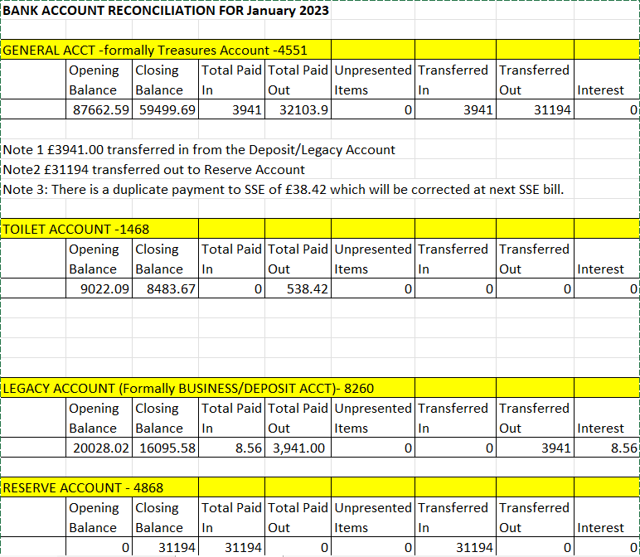
  - To receive the Quarterly Internal Audit Report
The Finance Committee carried out the Quarterly Internal Audit as required by the Terms of Reference. The findings are as follows:
    - No supporting document for Cheque number 00616. Document subsequently obtained and placed in folder.
    - Minutes from July 2022 not in the folder. The document subsequently located and placed in the folder.
    - Cheque Number:001647: No Invoice found. A copy of the invoice has been requested from the supplier.
    - FPO Payment for £416: Only a letter in support of a payment and not an invoice. Committee agreed it was too late to request a formal invoice.
    - It was noted that the payment of £38.42 for electricity was made from the General Account rather than the Toilets Account: Action Cllrs King and Collings

The conclusion from the findings was that more diligence be taken on filing documents and invoices. It was felt this shortfall has arisen with online banking.
It was noted that Scribe affords more robust checks to be made with invoices being stored within the software as well as in the paper system.
The audit report will be posted on the Council Website.

  - To agree or otherwise the selection of Internal Auditor as recommended by the Finance Committee
The Clerk reported that only two quotes had been received to date and that a third was needed before asking Council to consider a recommendation.
  - To receive the update on the Parish Asset Register
The Clerk reported that the inspection was complete apart from one item and that assets obtained in 2022/23 were being added to the Register.
The Clerk stated that unless otherwise instructed, the update would cover 2022/23 only and not previous years.

Cllr Bridge stated that the gritter needs treating for rust and repainting before it deteriorates further. The Clerk responded that there are other assets that need attention.
The Clerk stated that there should be three quotes for this work, and Cllr Tully responded that this is more specialist work, and we are unlikely to find three quotes.
This matter was not resolved.

  - To receive and agree or otherwise the recommendation of the Finance Committee regarding cyber-attack and data protection insurance.
The Clerk reported that the Finance Committee did not feel qualified to make a recommendation on this topic and asked if a volunteer Councillor could be allocated to Insurance.
Cllr Harris kindly agreed to undertake this work.
23/02/09: Clerk’s Report
Clerk’s Report February 2023
This Report is posted on the Parish Council Website.
Cllr Harris said he would contact Cavanna about the repair to the bank so that DCC are able to repair the stile.
It was noted that it is now too late for Cavanna to cut the hedge at the Narrows as it is now the bird nesting season.
23/02/10 Planning Matters
The recommendations of the Planning Working Party meeting (held immediately before this Council Meeting) were all agreed.
Action: The Clerk to submit the comments via the Planning portal of SHDC.
Action: The Clerk to seek an extension to the consultancy period for 2057/21/FUL.

23/02/11 Local Government Election Timetable of Proceedings for Thursday 4th May
Council noted the following upcoming events.
- Publication of Notice of Election – Thursday 23 March 2023
- Start of Nomination Process – 10am Thursday 23rd March 2023
23/02/12 King’s Coronation Celebrations
The Clerk stated that an initial road closure application has been submitted and that another more detailed submission still needs to be made.
Cllr Collings detailed the status of other Kings’ Coronation preparations as provided by Cllr King:
- Official Coronation Information Pack sent to the Clerk.
- Call for Volunteers to help with the weekend posted on PC website, Facebook page and SG good Neighbours page. I have requested an advert to be placed in the next Parish Mag. I have put a poster in the Church House Inn and Roz has put one in her shop. Richard Tully is the contact for any volunteers.
- It has been suggested that we supply a list of actual duties required for the 3-day event and post that in the same platforms and outlets.
- I have contacted Martin North and he is available to provide a street disco on the Saturday Evening (in the same format as the Jubilee celebrations) at a cost of £225. •
- I have looked at the cost of the Storytellers Chair for the Orchard/playpark and it is £546 + VAT. A brass commemorative plaque with King Charles emblem will be approx. £200. (This would need to come from jubilee funds, not the Legacy as per Anthony’s instructions)
Cllr Rowe stated that the WI are happy to organise the Children’s Tea Party at the Scout Hut and that they would want to be reimbursed by the Council for the costs.
There was a debate as to whether or not to have commemorative mugs ordered but it was felt that this would be too soon after the Queens’ Jubilee.
It was noted that the Church will be organising Cream Teas on the Monday.
The possibility of a Classic Car show, and a village photograph were discussed but nothing was agreed.
Cllr Rowe suggested setting up a WhatsApp group.
Cllr Callaghan said she would setup a Working Group.
Cllr Hawkins suggested the Council look at the commemorative plaques as used by the British Legion to place around the village.
The Clerk expressed a concern that his responsibility was restricted to the road closure and that he didn’t feel well placed to be involved further and that there didn’t seem to be clear leader for the celebrations.
The Council responded by agreeing the following responsibilities:
- Cream tea - Church
- Children’s Tea Party – WI
- Disco -Cllr King
- Hymns -Church
- Road Closure -Clerk
23/02/13 Community Building Update
Cllr Harris stated that he had circulated an update from the Solicitors.
Cllr Harris also sated that the legal fees will be £2500 not the £2000 as budgeted.
Council agreed that this is contained with the £10000 budget for the project and gave authourity for Cllr Harris to proceed.
Cllr Harris reported that interest in letting the building has been received from three parties.
23/02/14 Delegation of Powers to the Committees
  - It was agreed that the Finance Committee should have delegated powers, but this could not include setting the precept.
  - It was agreed that the Staffing Committee should have dedicated powers but this could not include appointing employees.
  - It was agreed that the Planning Committee (when formed) have delegated powers.
It was noted that all Councillors could be on the Planning Committee

Next steps were not discussed.

23/02/15 Exclusion of Press and Public
The Council resolved that in accordance with Paragraph 1 (2) of The Public Bodies (Admission to Meetings) Act 1960, the press and public be excluded from the meeting during consideration of the agenda item 16 owing to the confidential nature of the business to be transacted and the public interest would not be served in disclosing that information.
PART TWO
23/02/16 For Council to receive update on Hoyle Copse notice board.
Cllrs Tully and Harris stated that they would undertake the replacement of the posts within March.
The Council debated the next steps, and it was agreed to ask the complainant for a more detailed plan of the area.
Date/time of next meeting
7pm Monday 27th March 2023
Meeting Closed at 20:30

