STOKE GABRIEL PARISH COUNCIL
Minutes of the Finance Committee Meeting held on January 23rd 2023.
Present: Cllrs King (Chair), Collings, Blood, Tully,
In attendance: Cllrs Bridge and Harris
23/01/01f. Apologies for absence: Cllr Patch
23/01/02f Declaration of Interests / Dispensation requests: None
Standing Orders were suspended.
23/01/03f Public Participation; None
Standing Orders were reinstated.
23/01/04f Minutes of Previous Meeting: The minutes of the Finance Committee Meeting of 12th December 2022 were signed as a correct record.
23/01/05f Matters arising from the Committee Meeting Minutes of 12th December 2022
It was noted that the bank account for reserves is still to be set up.
It was noted that to date no internal auditor has been appointed yet.
Action: Cllr King to approach Cllr Callaghan and the Clerk of Kingswear Parish Council for possible internal auditors.
23/01/06f Invoices to be recommended to Council for payment at next Council Meeting
The invoices and Clerk’s expenses listed below were all accepted to be recommended for payment to the Parish Council.
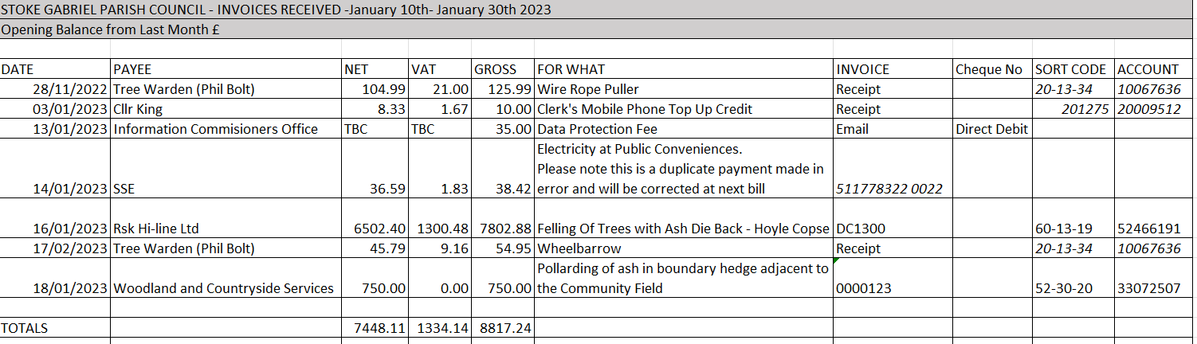
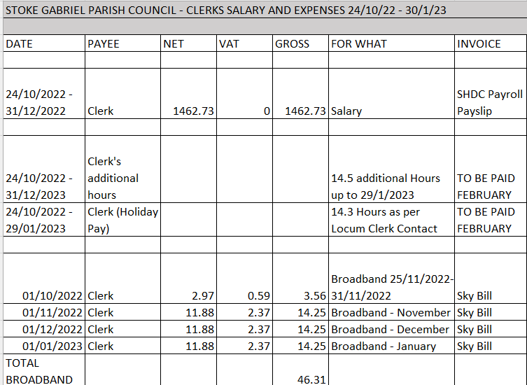
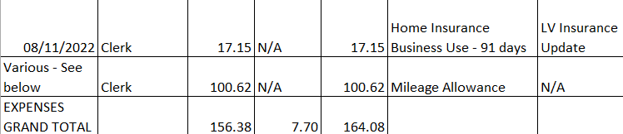
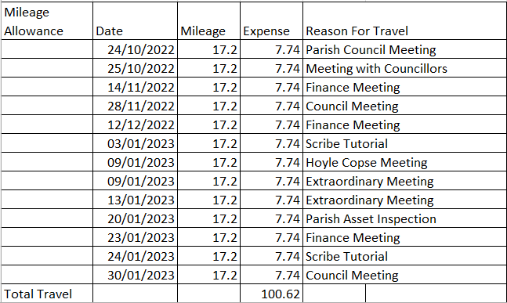

It was noted that the Council’s HMRC online account is showing overdue payments for March 2022.
Action: The Clerk to write to Hawthorns requesting they file a report for the previous Clerk for March 2022.
It was noted that the Council’s HMRC online account is showing overdue payments for the last three months.
Action: The Clerk to file reports for November 2022, December 2022 and January 2023.
It was noted that the previous Clerk’s backpay, paid by Council in November 2022 could result in Council having to make a payment to HMRC. This will be resolved when the Clerk submits the reports mentioned above.
23/01/07f Status of VAT return
It was agreed to wait for the previously submitted an online VAT126 form for the outstanding VAT Claim to be processed rather than resubmit the claim online,

2/01/08f Quarterly Report and Bank Reconciliation to Parish Council for December 2022
The bank accounts have been reconciled and details attached below.
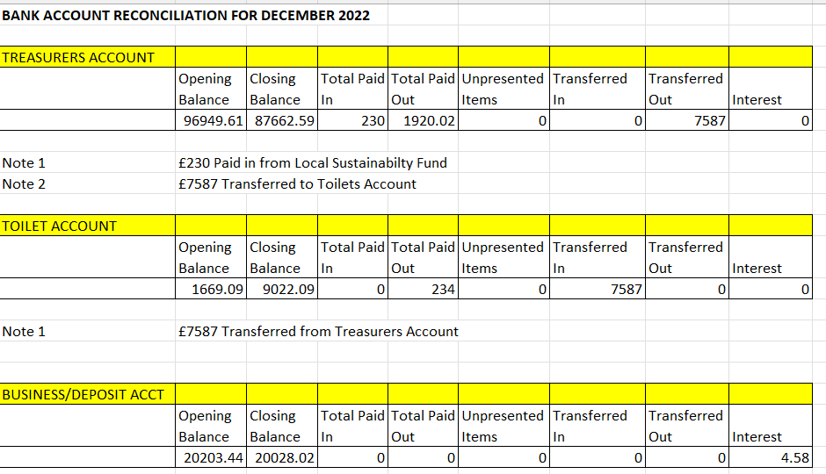
It was agreed to request of Council to delay the Quarterly Report until the data has been loaded into Scribe which will the produce the report.

23/01/09f Precept for 2023/24
The precept was discussed at length and agreed to be recommended to Council on 30th January 2023.
There is no change to precept submission of £49000 from 2022/23
Details as below.
Stoke Gabriel Parish Council Financial Plan 2023-24
 | Items | Precept 2022/23 | Precept 2023-24
Donations & | Training | £200.00 | £2,500.00
Subscriptions | SLCC/DALC subs | £350.00 | £385.00
 | Fireworks - 137 | £200.00 | £500.00
 | CAB - 137 | £150.00 | £0.00
 | CPRE - 137 | £150.00 | £165.00
 | Poppy Wreath | £25.00 | £40.00
 | Flowers | £100.00
ADMIN | Clerk's Salary | £11,300.00 | £8,500.00
 | Tax/NI | £700.00 | £0.00
 | Payroll | £120.00 | £100.00
 | Stat/Mile/office | £1,362.00 | £1,500.00
 | Computer | £100.00
 | Chairman's Allowance | £100.00 | £100.00
 | APM costs | £100.00 | £100.00
 | Insurance | £1,400.00 | £1,800.00
 | Audit - Internal | £100.00 | £110.00
 | Audit - External | £300.00 | £330.00
 | Bank Charges | £100.00 | £100.00
 | Safe Custody | £15.00 | £15.00
 | Website | £470.00 | £750.00
 | Rent for Meeting | £320.00 | £320.00
 | Election Costs | £1,413.00 | £0.00
 | Scribe |  | £600.00
Parish Asset | Playground Inspection | £250.00 | £275.00
Maintenance | CCTV | £100.00
 | Hanging Baskets | £550.00 | £605.00
 | Hoyle Copse | £3,000.00 | £3,300.00
 | Orchard | £200.00 | £500.00
 | Grass Maintenance | £7,000.00 | £8,400.00
 | Defib | £150.00 | £300.00
 | Tree Survey | £325.00 | £357.50
 | Bench Maintenance | £300.00 | £1,000.00
 | Drainage Works | £800.00 | £1,056.00
 | Playground | £500.00 | £550.00
 | War Memorial | £500.00 | £550.00
 | Noticeboard |  | £300.00
Parish Asset | Orchard | £300.00 | £3,000.00
Improvements
Accruals | Elec Costs future | £400.00 | £500.00
 | Toilet upkeep | £250.00 | £500.00
Reserves | Temp locum clerk | £300.00 | £800.00
 | Add. Tree works | £1,000.00 | £0.00
Village | Jubilee/Coronation | £2,500.00 | £2,500.00
Projects | Community Bldg. | £10,000.00
Unallocated | contingency | £500.00 | £550.00
Other | Ramp community Field |  | £3,000.00
 | Accessibility path HC |  | £3,000.00
Totals |  | £48,000.00 | £48,958.50

23/01/10f Inspection of Parish Council assets and update of register
Cllr King and the Clerk have commenced the annual inspection. Progress will be reported at the next Committee Meeting.
Action: Cllr King to update the Register.
Date and Time of Next Meeting: Not discussed.
Rob Barber
Clerk to Stoke Gabriel Parish Council 24th January 2023
07774 869 041

