STOKE GABRIEL PARISH COUNCIL
The Planning Working Party of Stoke Gabriel Parish Council will be held on Monday 27th March 2023 at 6.30pm in the Village Hall, Stoke Gabriel.
All members are summoned to attend for the purpose of transacting the following business. Members of the Public and Press are welcome to attend.

Please note the meeting is recorded for minute taking purposes.

Please note any items received by the Clerk during the week preceding the Meeting will be notified to the Working Party and added to the agenda for consideration.
AGENDA
1. Apologies - To receive and approve apologies for absence
2. Declaration of Interests – To receive any Declarations of Interest
3. Dispensation requests – To receive any Dispensation Requests.
The Committee will adjourn.

4 Public Participation - A total period of 10 Minutes will be allowed for members of the Public to ask questions or make any brief comment regarding the work of the Council or items on the agenda.

The Committee will reconvene.
5. For Council to agree or otherwise to support application by parishioners for connection to the public sewer system.
6. Planning Applications requiring the Parish Council to submit comment.
For the Planning Working Party to consider the following Planning Applications and provide recommendation for comment to the Parish Council for submission to the Planning officer.
6.1

6.2 Proposed Installation of Telecomms Cabinet
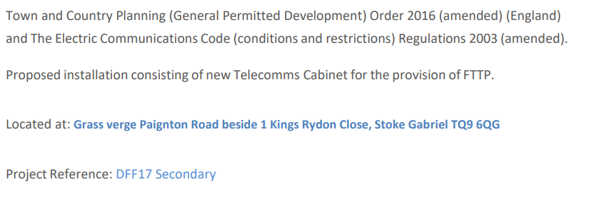
7. Planning Applications with no statutory consultancy.
For the Planning Working Party to note and advise the Parish Council
7.1
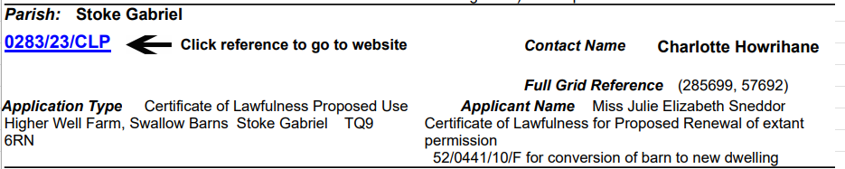
8. Planning Decisions notifications
For the Planning Working Party to note and advise the Parish Council
8.1
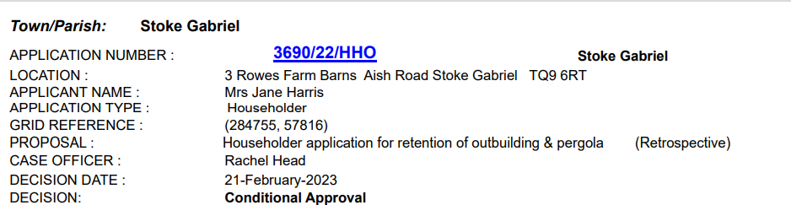
8.2
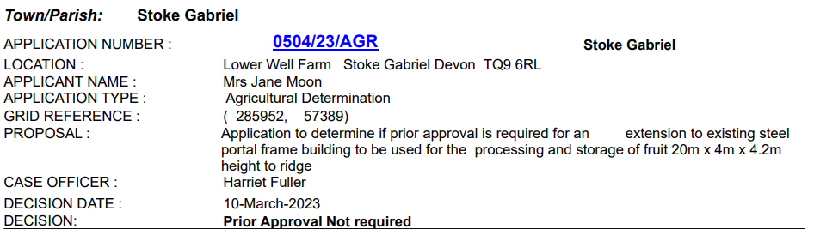

9. Tree Applications
For the Planning Working Party to note the recommendation of the Tree Warden and advise the Parish Council.
9.1
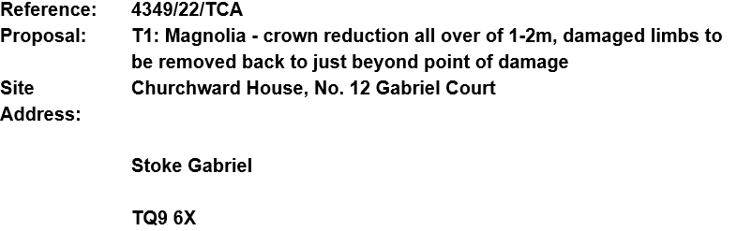

10. Tree Decisions
For the Planning Working Party to note and advise the Parish Council
10.1
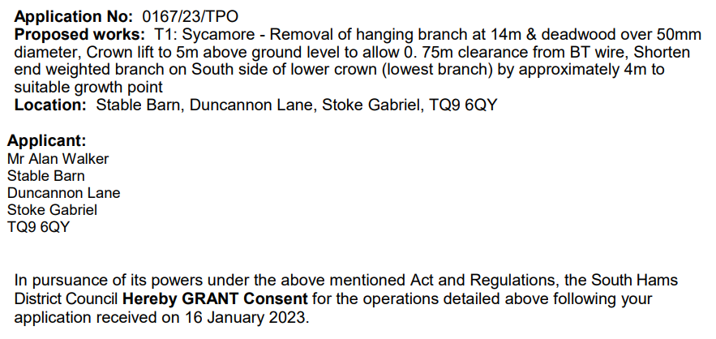

Time and Date of Next Meeting

Rob Barber Rob Barber – Clerk to Stoke Gabriel Parish Council

