Stoke Gabriel Parish Council

Minutes from the Parish Council Meeting held on 27th March 2023 at 7pm
Present: Cllrs Tully (Chair), King, Harris, Callaghan, Collings, Blood, Bridge, District Councillor Rowe, Rob Barber (Parish Clerk)
There were no members of the Public or Press present.
23/03/01 Apologies: Cllrs Patch and Fletcher, District Councillor, Bastone and County Councillor Hawkins
All apologies were approved and accepted.
23/03/02 Declaration of Interests - None
23/03/03 Dispensation Requests - None
Standing Orders were suspended.
23/03/04 Public Participation
Cllr Rowe raised a concern with a possible breach of the Planning process.
It was noted that this concern had been previously raised with SHDC Planning by Cllr Collings and further information had been requested by SHDC Planning which had subsequently been supplied.
It was also noted that the concern is not on the Enforcement list.
It was agreed that the concern be raised again with Planning.
Action: Cllr Collings to send the Clerk the original communication to SHDC and the response.
Action: The Clerk to raise the case with SHDC Planning.
Action: The Clerk to ensure the Enforcement is circulated to the Council.
23/03/05 Councillor Reports
District Cllr Rowe
The report is posted on the Parish Council Website
Cllr Rowe reminded the meeting of the need for voters to take ID when voting in the upcoming Election and stated that postal votes do not require ID.
Cllr Rowe kindly volunteered to take Councillors nomination forms to Follaton House.
Cllr Rowe reported that the garden waste collection service was going well.
Cllr Rowe confirmed that the planning for the Childrens’ Tea Party as part of the Kings’ Coronation Celebrations was going well. The Partys will take place in the Scout Hall.
It was also noted that the Council will reimburse the WI for costs associated with the Party.
District Cllr Bastone
The report is posted on the Parish Council Website
Standing Orders were reinstated.
23/03/06 Minutes from Previous Meeting
Cllr Callaghan noted that there was an error in the minutes from the Stoke Gabriel Parish Council Meeting held on 27th February 2023 and requested that this be corrected prior to signing.
The error was in item 23/02/14 Delegation of Powers to the Committees section b where the word dedicated was used when it should have been delegated.
The minutes were hand amended and the meetings were signed as a correct record.
23/03/07: Matters arising from previous meeting minutes.
Cllr Callaghan asked if the posts at Hoyle Copse will be replaced in March as previously agreed.
Action: Cllr Tully to communicate with the complainant.
23/03/08: Financial Matters
  - The list of payments to be made as listed below were all agreed.
The authorisation of Hoyle Copse expenditure and Clerks additional hours were also agreed for future payment.
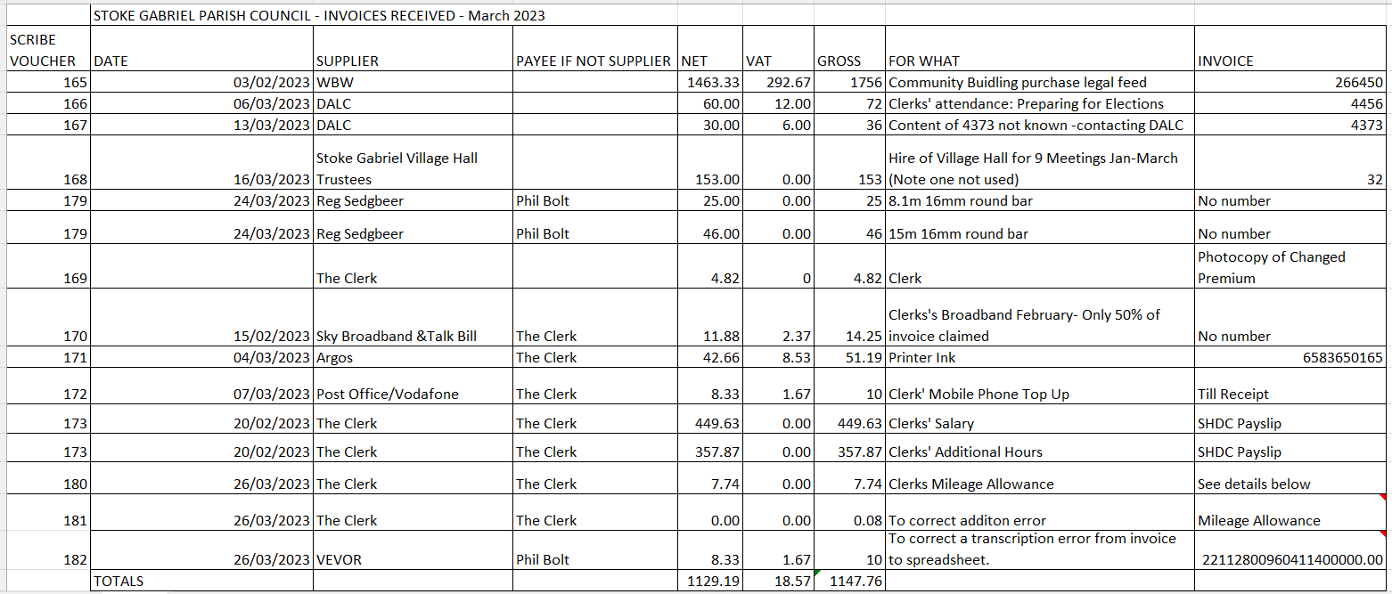
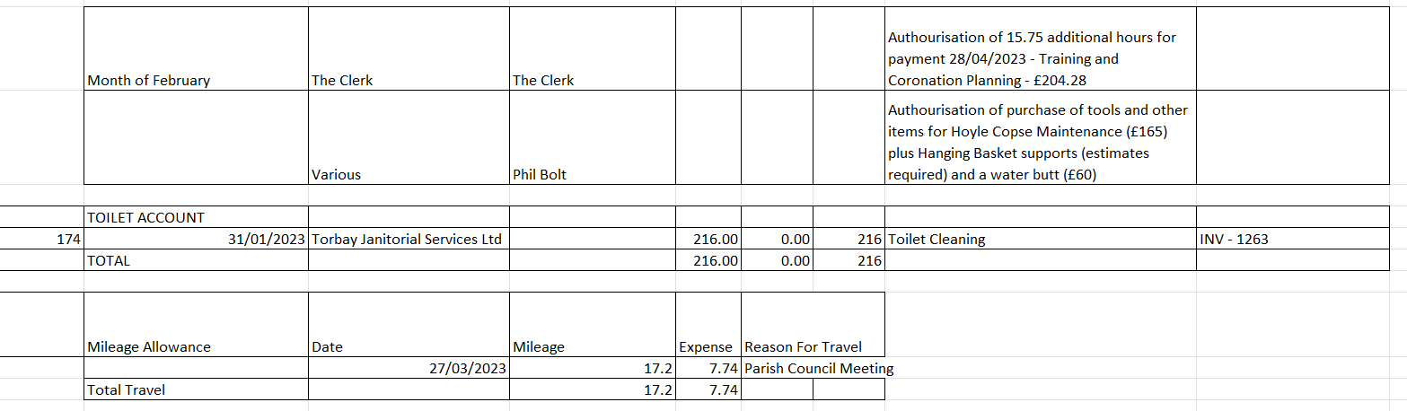

Post Meeting Note: Please note that DALC Invoice 4373 now obtained.

  - To receive the status of the VAT return (Clerk)
The Clerk reported that the VAT return has not been received to date.

  - Quarterly Report and Bank reconciliation

The Clerk stated that the Quarterly Report debate was now out of date, and he had now circulated the Net Position to date to Council in readiness for year end.

The Clerk stated that he would reissue this to Council at Year end to take into account any payments or receipts up to the ned of March.

The Bank Reconciliation for February is as attached below.
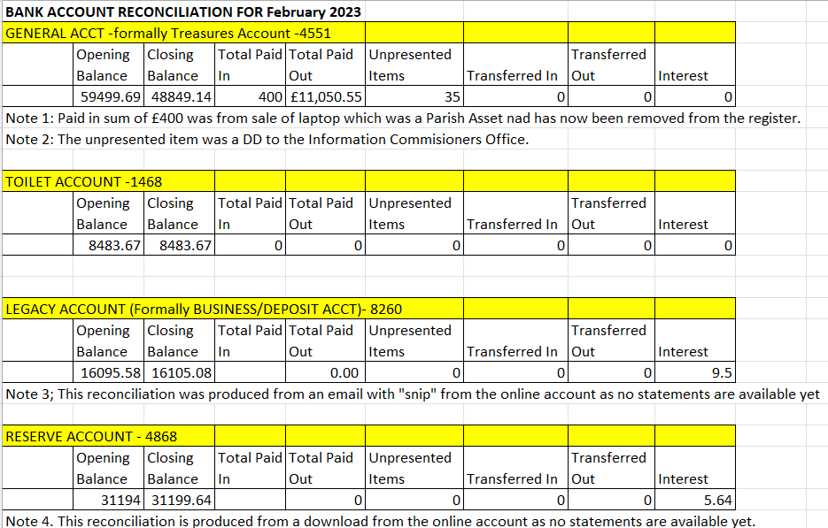

  - Quarterly Internal Audit Findings
The Clerk reported that the findings have been resolved and that the Report will be posted on the Council Website.
  - To agree or otherwise the selection of the Internal Auditor
Cllr Blood stated that the intended third quote to carry out the Internal Audit had not materialised.
It was agreed to proceed with the two quotes obtained to date and that a decision will be made at the Council Meeting in April.

  - Parish Asset Register
The Clerk reported that the update of the Register is now complete and has been posted on the Council Website.
The Clerk stated that there are a small number of concerns in the Register from previous years and reported that the Gritter is not on the Register.

Post Meeting Note: This statement by the Clerk regarding the gritter was incorrect.

  - Cyber-attack and data protection insurance
The Clerk reported that the Council currently does not have insurance against cyber-attack or for payment of an award resulting from a data protection breach.
Cllr Harris had kindly volunteered to review this topic and reported to Council that this insurance was needed.
Action: Clerk to approach other Councils to see how much other Councils are insured for on this topic.
Action: The Clerk to obtain quotes from the Council’s current insurers and to obtain further quotes.
  - Levelling of lane from old entrance into Hoyle Copse

Cllr Callaghan requested that this item be deferred until the requirements are further understood. This request was agreed.

23/03/09: Clerk’s Report
The Clerks’ Report is posted on the Council website. t
23/03/10 Planning Matters
All Councillors had been present at the Planning Working Party prior to this Council Meeting and so the recommendations made by the Working Party were all agreed.

23/03/11: Local Election Timetable of Proceedings for Thursday 4th May 2023
These were noted.
23/03/12: Kings’ Coronation Celebrations
12.1 Road Closure
Clerk reported that the fully detailed application has been submitted.
The required consultation with affected parties is nearing completion.
Ryan Harris has kindly volunteered to put in place the road closure signage as required by DCC.
12.2 Children’s Tea Party
Cllr Rowe reported that the preparation for this event is on plan.
It has been advertised in the School Newsletter
It was noted that the SGBA having a celebration on the Friday evening in their Boathouse.
It was noted that the Middle Wells Open Gardens 11am-5pm will be taking place.
12.3 Disco
Cllr king stated that unless there are 12-15 volunteers to help run the Celebrations and in particular the road closure then the Council will need to consider cancelling some or all of the Events.
It was agreed to ask Cllr Patch to prepare and post a poster in the shops and pubs asking for Volunteers.
12.4 Volunteers
It was noted that no volunteers have come forward to help with Coronation.
12.5 Story Tellers Chair
Cllr King reported that the cost will be £546 plus VAT plus cost of the base and a plaque.
It was agreed to ask P Collings to erect the base.
Cllr Tully stated that there is £2500 in the budget for the Coronation Celebrations.
Due to the time constraint with the approaching Coronation, it was agreed there was not enough time to obtain three quotes for the Story Tellers Chair.
It was agreed in principle to buy the chair.
It was noted that the Horticultural Society are enthusiastic about the sensory garden at the Orchard.
12.6 Hymns
The Clerk reported that he had been unable to contact the Church Verger for an update.
Action: The Clerk to contact Gerald
12.7 Cream Tea
The Clerk reported that he had been unable to contact the Church Verger for an update.
Action: The Clerk to contact
12.8 Next Steps – It was agreed to continue to seek Volunteers through a poster, Facebook etc.
23/03/13: Community Building Update
Cllr Harris reported that the legal acquisition process is ongoing.
Cllr Harris also reported that he is challenging the ownership of the fence between the electricity substation and the ancillary car park as he believes the fence is owned by the substation and not the Council.
Cllr Harris reported that two parties have applied for tenancy of the building and that he had circulated an update to Council that afternoon. Council discussed the two applications, and it was agreed that more information s required before an informed decision could be made.
Action: Councillors to send questions to Cllr Harris to ensure enough information will be available to select the best tenant.
Action: The Clerk to add an agenda item for tenant selection to the April 24th Meeting.
Cllr Collings requested that the selection of the tenant be made by Secret Ballot.
Action: The Clerk to review Standing Orders and ensure if possible that the Secret Ballot can take place.
It was noted that the tenant selection will need to be in a Part Two Meeting.
23/03/14 Neighbourhood Plan
Cllr Harris reported that three quotes have been received to produce a draft of the Neighbourhood Plan. The cost of this will be £7000 to £8000 but this will be covered by funding.
Cllr Harris reported that the Housing Needs Survey is out of date and no longer relevant and a new one is required. SHDC will do this, and the cost will be £3500. Use of SHDC will provide additional information.
It was noted that the Council has £17500 ring fenced in the reserves for the Neighbourhood Plan.
It was noted that the Community Land Trust will have an input to the Plan and Cllr Collings will instigate these conversations.
Cllr Harris reported that there will be an article in the Parish News encouraging Parishioners to complete the questionnaire.
It was note that the Four Cross Planning had been rejected due to the mix of houses.

23/03/15 Delegation of Powers to the Committees
It was agreed that the Finance Committee and the Staffing Committee will include Delegation of Powers as appropriate when their terms of reference.
It was noted that the Planning Working Party will need to write Terms of Reference when they become the Planning Committee and so include Delegation of Powers.
23/03/16 Scheme of Delegation
The Clerk stated that there is some provision in the Standing Orders and Financial Regulations and that he would review these and make recommendations to Council if there are any shortfalls.
23/03/17 Exclusion of Press and Public
The Council resolved that in accordance with Paragraph 1 (2) of The Public Bodies (Admission to Meetings) Act 1960, the press and public be excluded from the meeting during consideration of the agenda item 18 owing to the confidential nature of the business to be transacted and the public interest would not be served in disclosing that information.

Date/time of next meeting: 24th April 2023
PART TWO MEETING
23/03/18 Hoyle Copse Complaint
It was agreed that Council needs to obtain a larger scale map of the area around the notice board before it can respond.
Action: Cllr Harris to obtain the larger scale map.
Meeting Closed at 8.55pm

