STOKE GABRIEL PARISH COUNCIL
Please note this is issue 2 of the agenda.
Reason for reissue: Addition of Item 5.2 due to late Planning Application from SHDC.
The Planning Working Party of Stoke Gabriel Parish Council will be held on Monday 24th April 2023 at 6.30pm in the Village Hall, Stoke Gabriel.
All members are summoned to attend for the purpose of transacting the following business. Members of the Public and Press are welcome to attend.

Please note the meeting is recorded for minute taking purposes.

AGENDA
1. Apologies - To receive and approve apologies for absence
2. Declaration of Interests – To receive any Declarations of Interest
3. Dispensation requests – To receive any Dispensation Requests.
The Committee will adjourn.

4 Public Participation - A total period of 10 Minutes will be allowed for members of the Public to ask questions or make any brief comment regarding the work of the Council or items on the agenda.

The Committee will reconvene.

5. Planning Applications requiring the Parish Council to submit comment.
For the Planning Working Party to consider the following Planning Applications and provide recommendation for comment to the Parish Council for submission to the Planning officer.
5.1
Please note the Comments to be received date has been moved to 8th May 2023
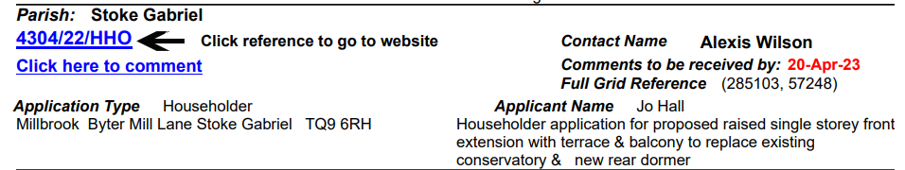
5.2
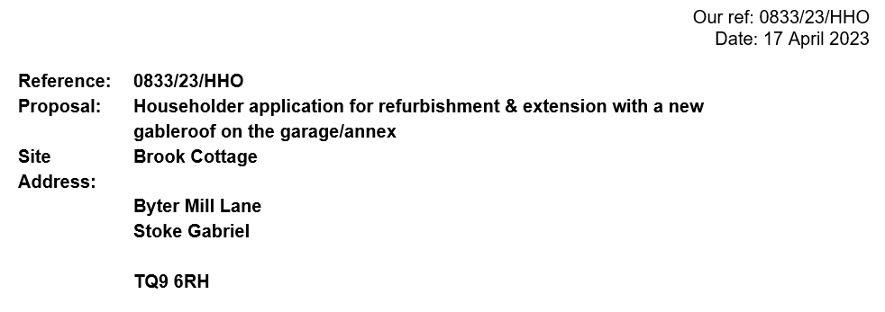
6. Planning Applications with no statutory consultancy.
For the Planning Working Party to note and advise the Parish Council
No Applications

7. Planning Decisions notifications
For the Planning Working Party to note and advise the Parish Council
7.1
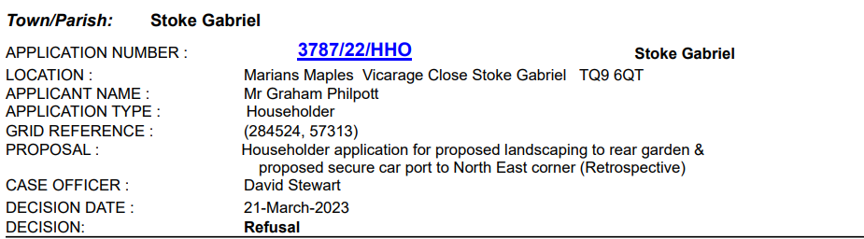

7.2
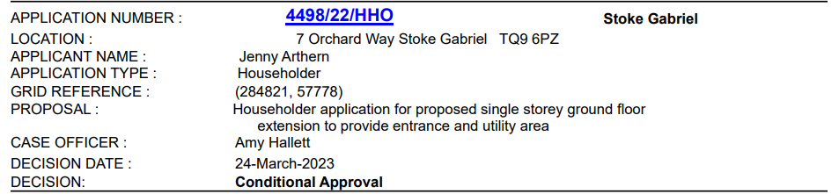
7.3
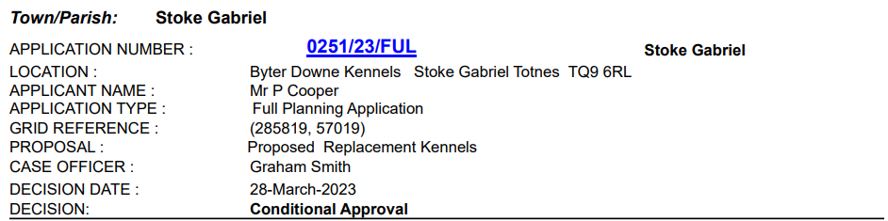
7.4
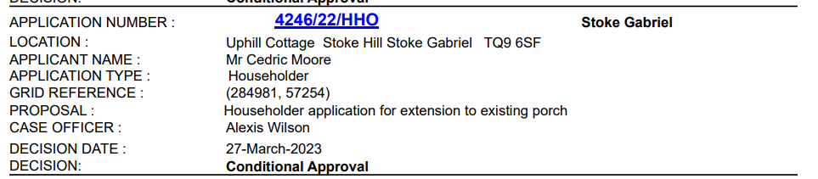
7.5
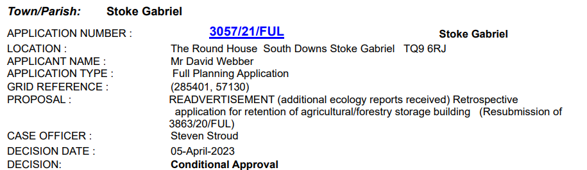

8 Planning Applications Withdrawn
8.1
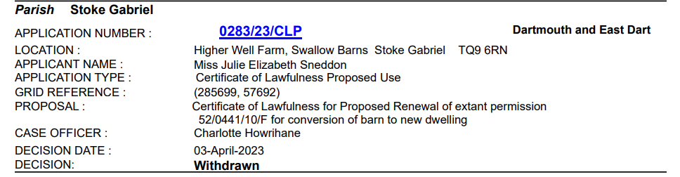

9. Tree Applications
For the Planning Working Party to note the recommendation of the Tree Warden and advise the Parish Council.
None
10. Tree Decisions
For the Planning Working Party to note and advise the Parish Council
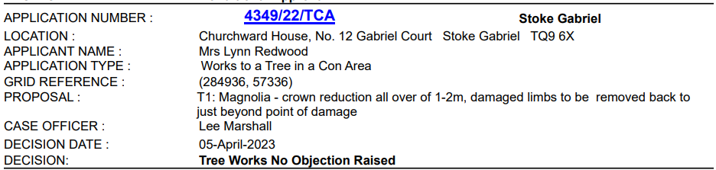
Time and Date of Next Meeting
Time To be advised.
22nd May 2023

Rob Barber Rob Barber – Clerk to Stoke Gabriel Parish Council

