Stoke Gabriel Parish Council

Minutes from the Parish Council Meeting held on 24th April 2023 at 7pm
Present: Cllrs Tully (Chair), Harris, Callaghan, Collings, Bridge, King, District Councillor Rowe, County Councillor Hawkins,2 members of the public, Rob Barber (Parish Clerk)
23/04/01 Apologies: Cllrs Patch, Fletcher, Blood
All apologies were approved.
23/04/02 Declaration of Interests -None
23/04/03 Dispensation Requests - None
Standing Orders were suspended.
23/04/04 Public Participation
There was no public participation.
23/04/05 Councillor Reports
District Cllr Rowe
The report is posted on the Parish Council Website
There were no additions to the written report.
District Cllr Bastone
The report is posted on the Parish Council Website
Cllr Bastone thanked those Councillors who were standing down for their hard work.
Cllr Bastone thanked Cllr Tully for 28 years work on the Council.
County Councillor Hawkins
Cllr Hawkins said it has been a pleasure to work with Stoke Gabriel Parish Council.
He reported that there had been a meeting at Devon County Council and that Highways needs to be a priority over the upcoming years.
Dartmouth Town Council have purchased three vehicle speed signs.
Cllr Hawkins said farewell to Cllr Tully and that it has been a pleasure to work with him, and that it was a shame there were no new Councillors standing for election.

Standing Orders were reinstated.
23/04/06 Minutes from Previous Meeting
The minutes from the Stoke Gabriel Parish Council Meeting held 27th March 2023 were signed as a correct record.
23/04/07: Matters arising from previous meeting minutes.
Cllr Callaghan requested that there is an item on the May agenda for an update on Hoyle Copse and that it be included in a Part Two Meeting.
23/04/08: Financial Matters
23/04/08.1 The list of payments to be made as listed below were all agreed.
Cllrs Colling and King challenged the Clerks expense claim for Broadband but nothing was resolved.
It was noted that the pre-authorisation for purchase of a computer hard drive was not authourised as Cllr Collings would make available one for the Clerks’ use.

On-line payments will be transacted after the meeting.

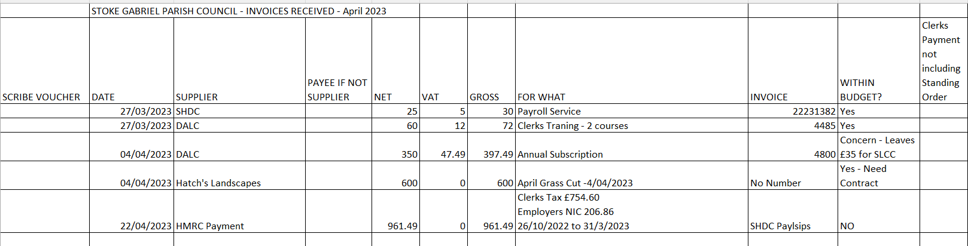
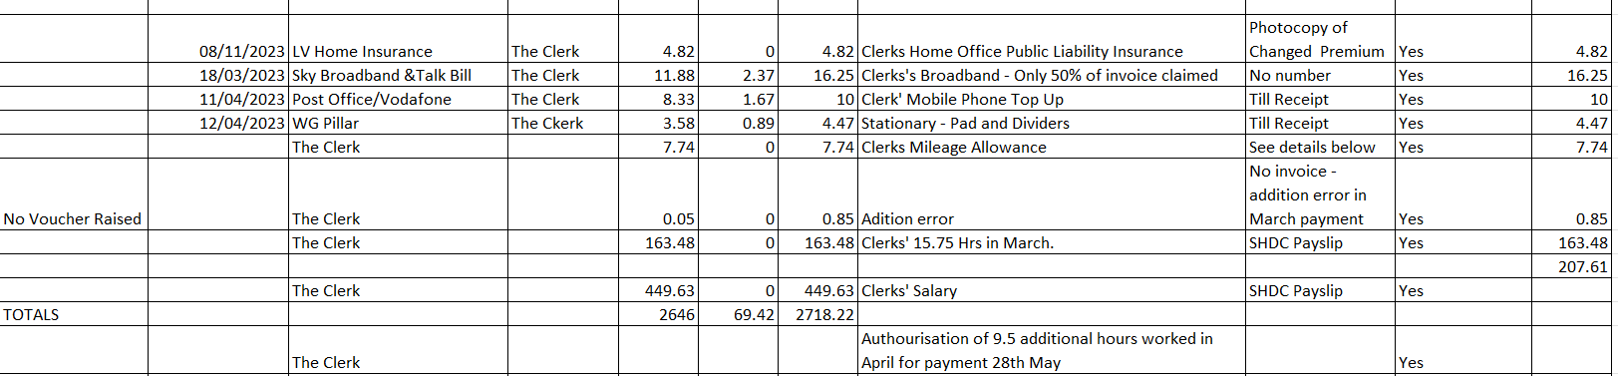

23/04/08.2 It was noted that the VAT repayment has not yet been received.
23/04/08.3 It was noted that the Monthly Bank reconciliation has been enacted. Please see notes for detail.
This reconciliation is up to year end and so reflects the status at year end.

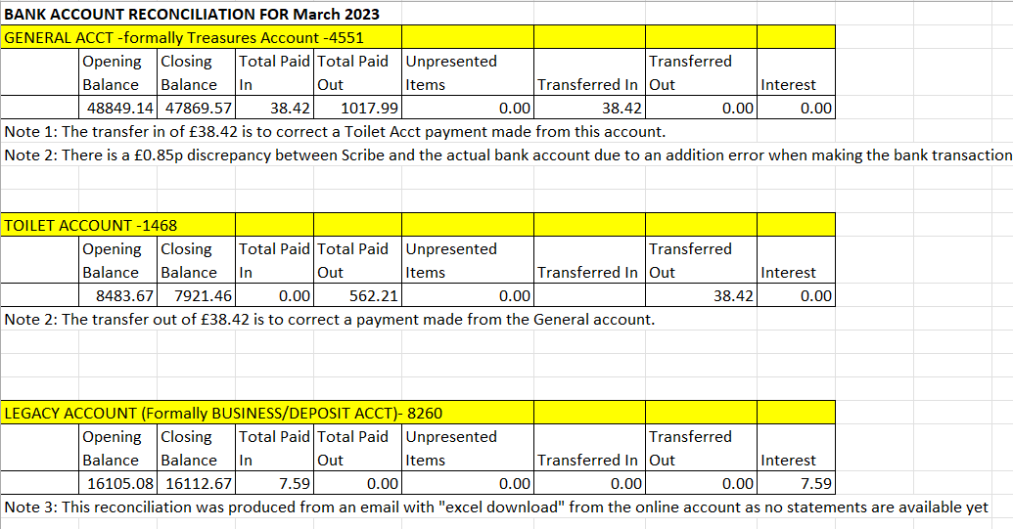
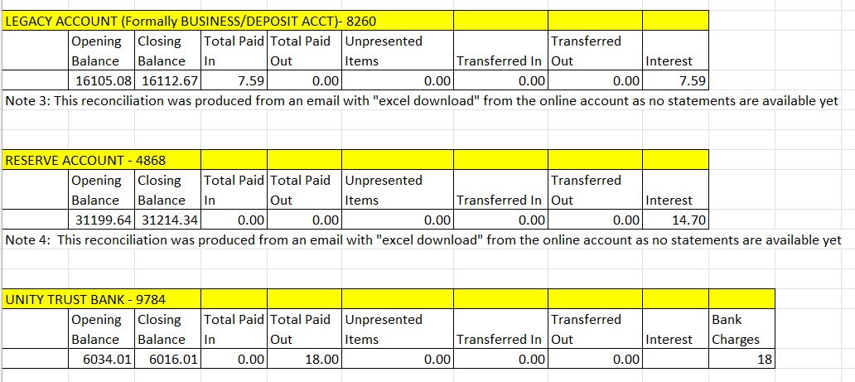

23/04/09: Clerk’s Report
The Clerk’s Report is as posted on the Website.
23/04/10 Planning Matters
During the public participation agenda item of the Planning Working Party Mr Dixon outlined plans for improved access to and from Sharpham Barton Wines onto the Waddeton Road.
Tt was noted that these works would be carried out in one day, with an initial proposed date of 20 May 2023.
All neighbours and the four caravan parks in the area will be notified when the date is confirmed.
Signage for the diversion was discussed as was drainage of surface water.
Council had no objections to the proposed works.

The recommendations of the Planning Working Party regarding Planning Applications were accepted by Council.
Details as below:
Planning Application 4304/23/HHO
Council comment submitted: Stoke Gabriel Parish Council wish to see further surveys to be carried out to determine the types of bats present and also wish to see details of the mitigations to be put in place to meet the needs of the Countryside Act.

Planning Application: 0833/23/HHO

Council comment submitted: Support.

Action: Clerk to submit these on the SHDC planning portal.

23/04/11 Local Election – Co-opting of Councillors
There was a brief discussion around the co-option process and the Clerk said that all details were contained in a DALC Newsletter and in an email circulated by the Election Services Manager.
It was agreed to place notices on the Council Website, Good Neighbours Facebook Page and in the Parish Magazine.

23/04/12: King’s Coronation Celebrations
12.1 Road Closure
The Clerk reported that road closure had finally been agreed but that his name was still on the application as responsible person.
Cllr Tully agreed to be the responsible person.
12.2 Childrens’ Tea Party
It was noted that this would be from 3pm to 5pm and that all children must be accompanied by an adult.
12.5 Story Tellers Chair
Cllr King reported that the Story Tellers Chair under consideration was not wide enough for aa adult and child to sit on together. Cllr King had now sourced a bigger chair with a choice of wood.
It was agreed that the chair should be made of oak owing to it’s greater durability when compared to fir.
The cost of a chair made from oak is £725 excluding VAT.
The cost of the chair made from fir is £540 excluding VAT.
Both chairs will need a concrete base.
A parishioner has kindly offered to deliver the chair.
Cllr Harris requested that the dimensions of the chair be communicated clearly to the chair maker I order to ensure the chair would be of the correct size.
12.6 Hymns
It was noted that the Hymns will be as part of a Special Church Service rather than at the Mill Pond.
12.7 Cream Tea
It was noted that this will be Coffee and Cake and there are posters around the Village for this event.
23/04/13: Amendment to Standing Orders to incorporate Secret Ballots.
It was agreed this was not required.
23/04/14: Amendment to Financial Regulations
Cllr King commented that the proposed change was not relevant to Stoke Gabriel as we do not have Directors.
It was agreed that the quotes for Cyber-attack insurance were too expensive.
It was noted that of the Councils who had responded to the Clerks ballot on whether they had such insurance, only Dartmouth Town Council had the insurance. Brixham Town Council do not have this insurance. No Parish Councils have responded to the ballot.
It was suggested that Kingswear Parish Council may have a joint policy with other Parish Councils, and this was worth investigating.
Action: The Clerk to liaise with Kingswear Parish Clerk to determine if this is the case.
23/04/15: Community Building Update
Cllr Harris reported that he had received communication from Solicitors confirming the boundary fence belongs to the National Grid.
Please also see Agenda Item 19 in the Part Two Meeting.
23/04/16 Neighbourhood Plan
Cllr Harris reported he was liaising with South Hams District Council as to when they will complete the questionnaire.
23/04/17 CCTV for the Public Toilets
Cllr Callaghan suggested the Council put an article in the Parish Magazine and agreed to write it.
Cllr Bridge agreed to a approach parishioner to see if they would agree to CCTV being installed on a pole on his property.
It was also noted that the CCTV could be installed on a pole on Council property.
A concern was raised as to what view the camera would have of the area.
Another concern was raised as to whether the camera could record the malicious damage taking place.
Cllr Bridge volunteered to obtain quotes for the equipment.
It was agreed in principle to proceed with CCTV at the public toilets pending costs.
23/04/18 Exclusion of Press and Public
The Council resolved that in accordance with Paragraph 1 (2) of The Public Bodies (Admission to Meetings) Act 1960, the press and public be excluded from the meeting during consideration of the agenda items 19,20 and 21 owing to the confidential nature of the business to be transacted and the public interest would not be served in disclosing that information.
23/04/19 Selection of Tenants for the Community Building

The Clerk stated that he had a written statement from Cllr Blood that he had been requested to read out. Council responded by saying that a Councillor could not have an input to a debate if not present.

There was a full discussion around the merits of both applicants.

Cllr Bridge proposed a motion to select a preferred tenant. This motion was seconded by Cllr King
A preferred tenant was agreed unanimously.

Cllr Collings proposed an amendment whereby further negotiations take place with the preferred tenant prior to final selection. This amendment was seconded by Cllr King.

It was agreed unanimously to have further negotiations with the preferred tenant prior to final selection.

23/04/20 Selection of Internal Auditor

It was agreed that the quotes from the two Internal Auditors selected were too expensive.

Cllr Callaghan agreed to send the Clerk a link to a list of Internal Auditors so that the search could be widened.

It was also noted that other Parish Clerks can carry out an Internal Audit providing there is not a reciprocal agreement.

Action: The Clerk to approach other Parish Clerks to see if there are prepared to provide this service.

23/04/21 Selection of Insurance Broker for Cyber Attack Insurance and Data Protection Breach Claim.

The topic of Cyber Attack insurance was fully discussed in Agenda Item 14 where it was agreed not to pursue such insurance without a further review of options.

Further final thanks to Cllr Tully

The meeting closed with final thanks to Cllr Tully for his contribution to the Council and Village over the last 28 years.

Date/time of next meeting
7pm Monday 22nd May 2023
Meeting Closed at 8.50pm

