STOKE GABRIEL PARISH COUNCIL
The Planning Working Party of Stoke Gabriel Parish Council will be held on Monday 15th May 2023 at 6.30pm in the Village Hall, Stoke Gabriel.
All members are summoned to attend for the purpose of transacting the following business. Members of the Public and Press are welcome to attend.

Please note the meeting is recorded for minute taking purposes.

AGENDA
1. Apologies - To receive and approve apologies for absence
2. Declaration of Interests – To receive any Declarations of Interest
3. Dispensation requests – To receive any Dispensation Requests.
The Committee will adjourn.

4 Public Participation - A total period of 10 Minutes will be allowed for members of the Public to ask questions or make any brief comment regarding the work of the Council or items on the agenda.

The Committee will reconvene.
5. Planning Applications requiring the Parish Council to submit comment.
For the Planning Working Party to consider the following Planning Applications and provide recommendation for comment to the Parish Council for submission to the Planning officer.
5.1
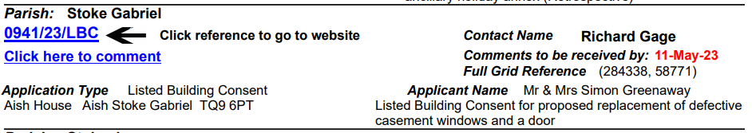
5.2
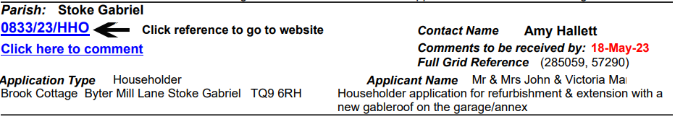
5.3
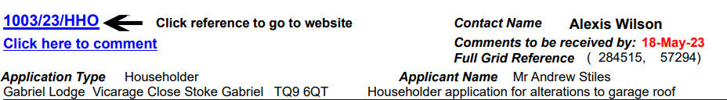

5.4
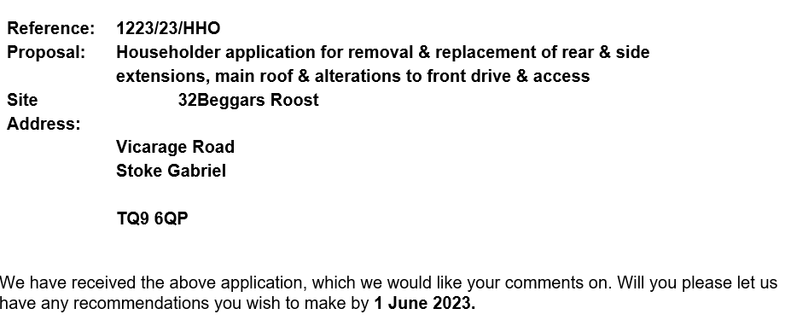
5.5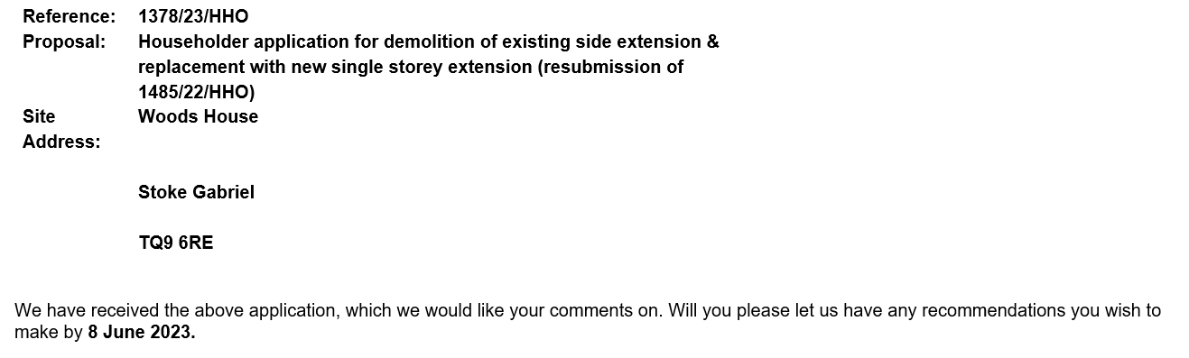
5.6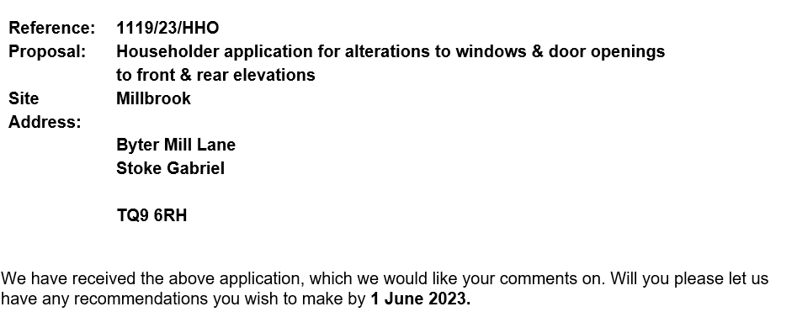

5.7
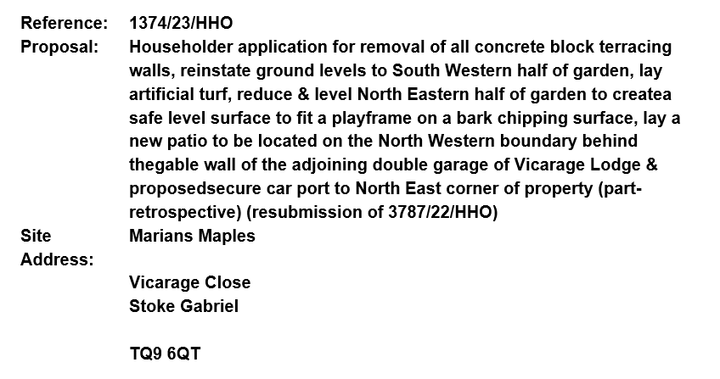

5. 8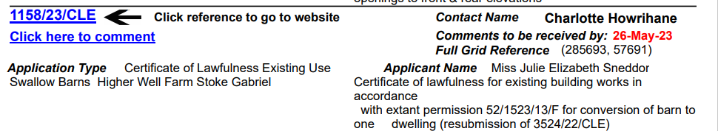

6. Planning Applications with no statutory consultancy.
For the Planning Working Party to note and advise the Parish Council
None

7. Planning Decisions notifications
For the Planning Working Party to note and advise the Parish Council
7.1
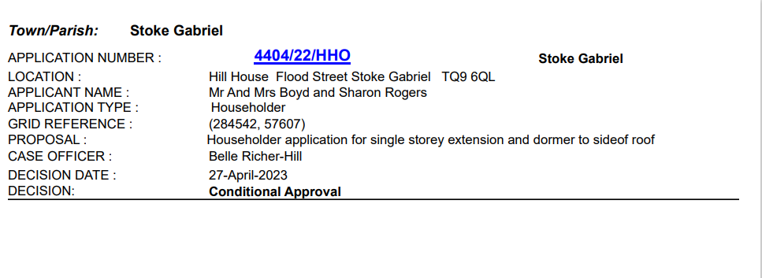

8 Planning Applications Withdrawn
For the Planning Working Party to note and advise the Parish Council
None
9. Tree Applications
For the Planning Working Party to note the recommendation of the Tree Warden and advise the Parish Council.
9.1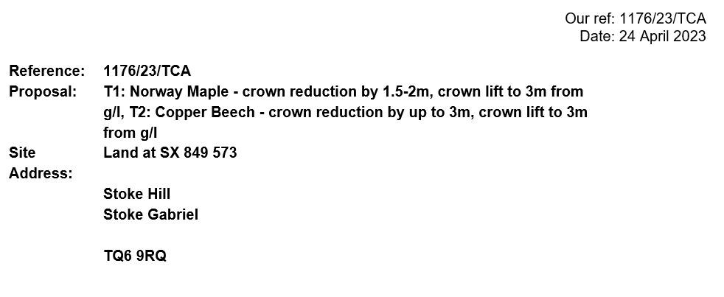

10. Tree Decisions
For the Planning Working Party to note and advise the Parish Council
None

Time and Date of Next Meeting
TBA

Rob Barber Rob Barber – Clerk to Stoke Gabriel Parish Council

