Community Furniture | LOCATION | QTY | 2019 COMMENT | Owner / Donated by | Picture of Bench
BENCH 1 | HOYLE COPSE by New Woods | 1 | OK | SGPC | 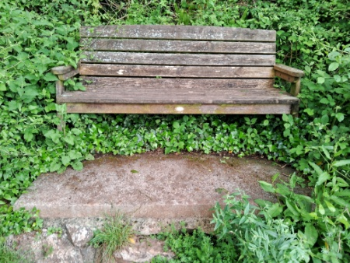
BENCH 2 | HOYLE COPSE by lime kiln | 1 | OK | SGPC | 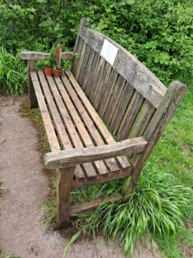
BENCH 3 | HOYLE COPSE by quarry | 1 | OK, No concrete plinth | SGPC / Helen Wilcox | 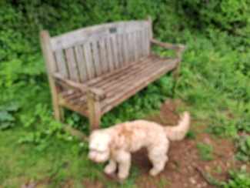
BENCH 4 | HOYLE COPSE in Field | 1 | OK, No concrete plinth | SGPC / Hannaford-Hill | 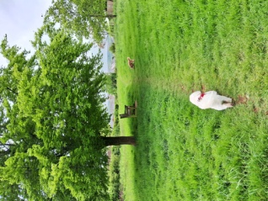
BENCH 5 | ORCHARD | 1 | OK | SGPC | 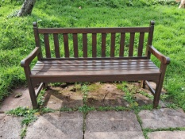

BENCH 6 | ORCHARD | 1 | OK - Needs cleaning | SGPC | 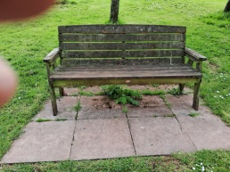
BENCH 7 | ORCHARD | 1 | OK - Needs cleaning, concrete plinth to short | The Hurst family | 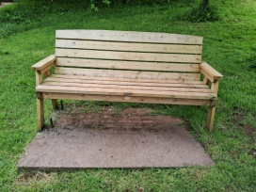
BENCH 8 | ORCHARD | 1 | OK - Needs Re-staining | SGPC / Denis Hinton | 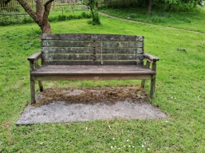
BENCH 9 | PLAYGROUND | 1 | Needs to be replaced, No concrete plinth. REMOVED. | SGPC | 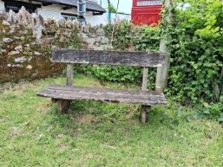
BENCH 10 | BYTER OP COMBE SHUTE | 1 | OK | SGPC | 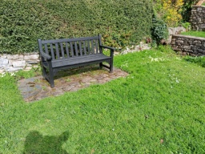
BENCH 11 | ORCHARD CLOSE by Entrance | 1 | OK | SGPC / AH Stoneham | 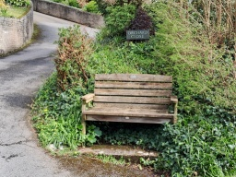
BENCH 12 | WAR MEMORIAL | 1 | OK | SGPC | 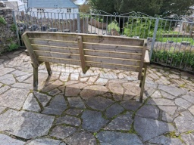
BENCH 13 | OPPOSITE WAR MEMORIAL | 1 | OK - Needs securing | SGPC | 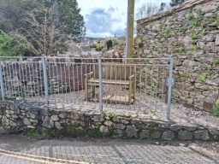
BENCH 14 | VILLAGE CENTRE BUS STOP | 1 | OK - Needs Re-staining | SGPC | 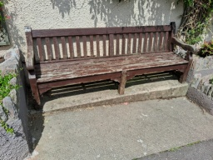
BENCH 15 | DUNCANNON LANE | 1 | Needs to be replaced, No concrete plinth  REMOVED | SGPC | 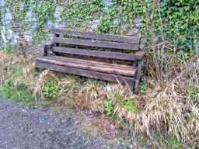
BENCH 16 | BARN PARK AND YEOLANDS | 1 | OK - Needs Re-staining | SGPC | 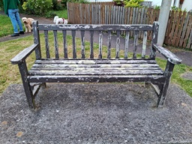
BENCH 17 | RYDON CROSS | 1 | OK - Needs Re-staining | SGPC | 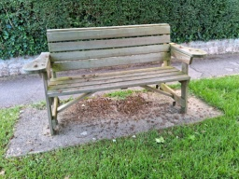
BENCH 18 | PORDS BRIDGE | 1 | OK | SGPC | 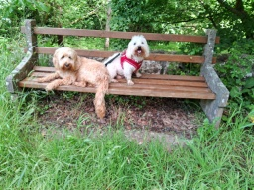
BENCH 19 (not on map) | WADDETON | 1 | Repaired | SGPC | 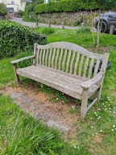
TABLE (not on map) | PICNIC TABLE IN ORCHARD | 1 | OK - Needs Re-staining | SGPC / Pam Wigfall | 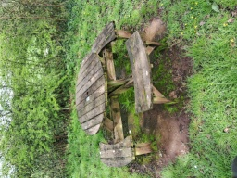
The items below are not SGPC property
BENCH | MILL POND/RIVERSHCK | 9 | Managed by P Lugg | P Lugg property
BENCH | MILL POINT | 3 | Managed by SGBA | SGBA property

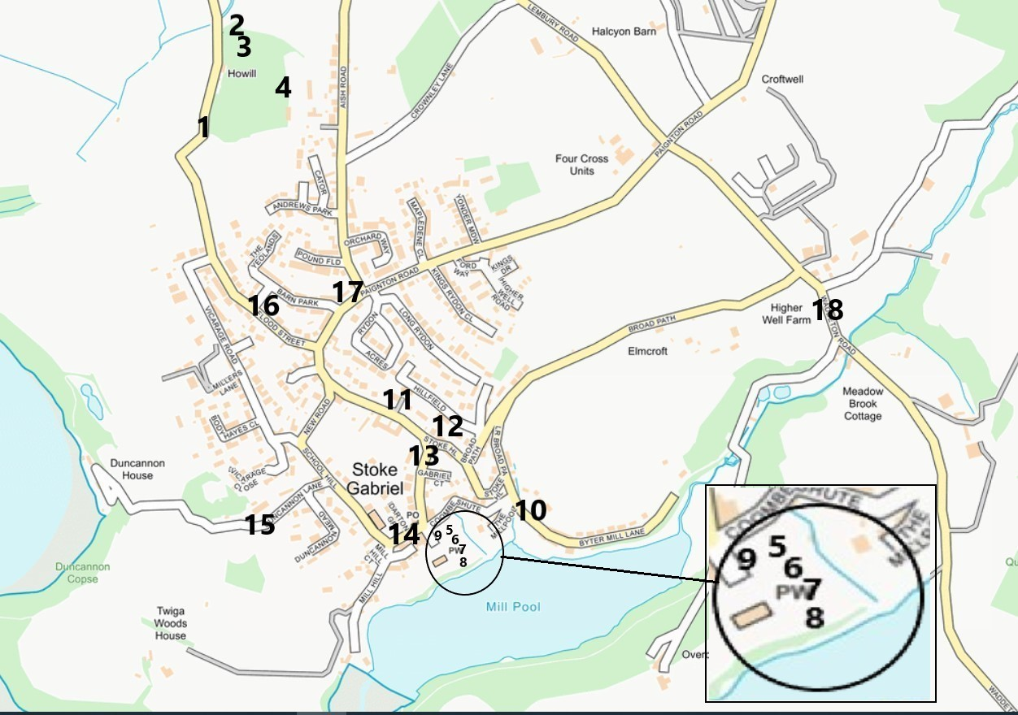
Summary:

Community Furniture | LOCATION | QTY | 2019 COMMENT | Owner/Donated by
BENCH 1 | HOYLE COPSE by New Woods | 1 | OK | SGPC
BENCH 2 | HOYLE COPSE by lime kiln | 1 | OK | SGPC
BENCH 3 | HOYLE COPSE by quarry | 1 | OK | SGPC / Helen Wilcox
BENCH 4 | HOYLE COPSE in Field | 1 | OK - No concrete plinth | SGPC / Hannaford-Hill
BENCH 5 | ORCHARD | 1 | OK | SGPC
BENCH 6 | ORCHARD | 1 | OK - Needs cleaning | SGPC
BENCH 7 | ORCHARD | 1 | OK - Needs cleaning, concrete plinth too short | SGPC
BENCH 8 | ORCHARD | 1 | OK - Needs Re-staining | SGPC / Denis Hinton
BENCH 9 | PLAYGROUND | 1 | Needs to be replaced, No concrete plinth, Removed | SGPC
BENCH 10 | BYTER OP COMBE SHUTE | 1 | OK | SGPC
BENCH 11 | ORCHARD CLOSE by Entrance | 1 | OK | SGPC / AH Stoneham
BENCH 12 | WAR MEMORIAL | 1 | OK | SGPC
BENCH 13 | OPPOSITE WAR MEMORIAL | 1 | OK - Needs securing | SGPC
BENCH 14 | VILLAGE CENTRE BUS STOP | 1 | OK - Needs Re-staining | SGPC
BENCH 15 | DUNCANNON LANE | 1 | Needs to be replaced, No concrete plinth | SGPC
BENCH 16 | BARN PARK AND YEOLANDS | 1 | OK - Needs Re-staining | SGPC
BENCH 17 | RYDON CROSS | 1 | OK - Needs Re-staining | SGPC
BENCH 18 | PORDS BRIDGE | 1 | OK | SGPC
BENCH 19 (not on map) | WADDETON | 1 | OK - Repaired | SGPC
TABLE (not on map) | PICNIC TABLE IN ORCHARD | 1 | OK - Needs Re-staining | SGPC / Pam Wigfall
The items below are not SGPC property
BENCH | MILL POND/RIVERSHCK | 9 | Managed by P Lugg | P Lugg property
BENCH | MILL POINT | 3 | Managed by SGBA | SGBA property

